Statistical Analysis of Bubble and Crystal Size Distributions: Application to Colorado Plateau Basalts

Alexander A. Proussevitch, Dork L. Sahagian

Climate Change Research Center and Department of Earth Sciences, University of New Hampshire, Durham, NH 03824
Email – alex.proussevitch@unh.edu, dork.sahagian@unh.edu (corresponding author)

Submitted to Journal of Volcanology and Geothermal Research,
July 00, 2004
Abstract

1. Introduction

Studies of bubble size distributions were not systematic.

There was recent interest in studying bubble size distributions in volcanic rocks since it is believed that they reflect some critical information about magma history and physical processes in the vent and surface lava flows.

Three aspects of vesiculation physics were targeted by bubble size distribution studies:
- Single nucleation and bubble growth event.
- Multiple nucleation and extended growth events.
- Coalescence.

All studies used non-systematic analytical tools to do statistical analysis so that results were hard if possible at all to compare. There were two distribution functions reported to describe bubble populations (exponential and power). The latter one was not actually a statistical function and it was able to fit distributions only at their wings for small and for large bubble while it was failing to treat intermediate sizes, and never mind it could not provide meaningful match between the small and large ones.

There was a confusion and misunderstanding of some basic statistical definitions such as bubble number density (BND).

This paper proposes a strict and systematic statistical approach and procedures to analyze bubble and crystal size distributions. We show that bubble and crystal distributions are all belong to logarithmic family of statistical distributions.

Four most common and appropriate distributions are given in the paper that fit bubble populations the best.

We go over step by step showing how to treat logarithmic distributions and understand them.

A critical step in the analysis is a conversion logarithmic distribution into linear style that opens a door to their clear understanding and physical interpretation.

2. Sample collection

We have used collection of 98 samples of Cenozoic basalts from Colorado Plateau (Fig. 1). All samples were collected by pairs from quenched crusts at the top and bottom of lava flows. The primary goal to have the collection of the sample pairs is an application of vesicular basalts for Colorado Plateau Paleoelevation and uplift history [Sahagian, 2002 #6769; Sahagian, 2002 #6773]. Now we use this collection for the statistical analysis of bubble population.

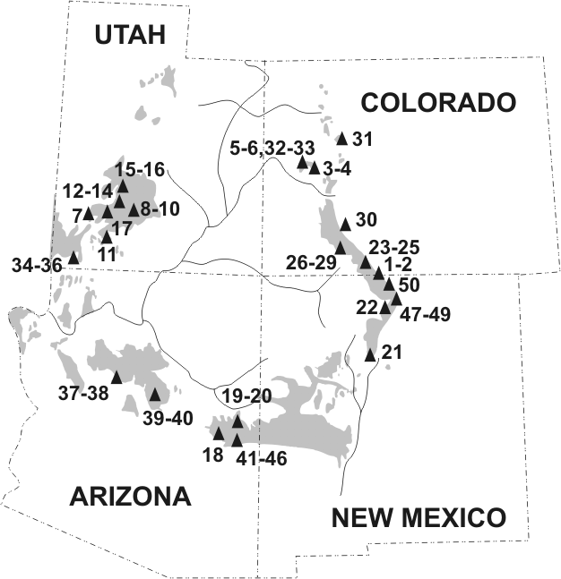
Figure 1. Sample localities of Colorado Plateau basalt from the collection. Cenozoic lava fields are shaded. Sample numbers correspond to those of Table 1.

As you can see from Figure 1 all volcanic fields are located around rims of the Plateau and presented mostly by Oligocene to Miocene volcanic formations with composition ranging from andesites to olivine basalts. These formations are found mostly in Northern rims of the Plateau. Younger Miocene to Quaternary basalts are tended to be around the Southern rims and presented by continental tholeiitic basalts. Accordingly the basalt samples have been collected from these volcanic fields but not differentiated by age or petrology since the focus of this study is statistics.

3. Sample analytics

In order to do the statistical analysis we needed to produce bubble population data for each sample which is in fact a dataset of individual bubble sizes (volumes) in a sample. We have used High Resolution X-Ray computed tomography (CT) imagery that then had been processed by object recognition procedures that have been developed by the authors. Let us describe each of these two analytical steps.

High Resolution X-Ray CT has been performed at the University of Texas in Austin using a technique specifically developed for geoscience’s applications [Ketcham, 2001 #6638]. A cylindrical core was drilled out from each sample and its 24 mm in diameter section was scanned to produce 3-dimentional attenuation array with the size of 512x512x351 or 1024x1024x696 and resolution of 46.9 and 23.4 μm accordingly. The higher resolution arrays then have been re-sampled to 512x512x348 dimensions in order to coarsen the resolution and make it same as the other scans (46.9 μm) and also to avoid computer resources problem to process the data.

Attenuation data is directly relates to local sample density and in turn needs to be segmented to solid material and voids. We have used a kriging thresholding algorithm to perform the segmentation [Oh, 1999 #7397] with moving window semivariogram of 10 voxels maximum lag distance. The segmented data have been processed by peeling technique of convex object recognition routine described in [Proussevitch, 2001 #5800].

The resulting dataset of bubble population counted from about 2000 to 50000 bubbles in each sample and probably represent the most accurate and representative bubble size data that have ever been available for statistical analysis. Individual bubble sizes in the datasets ranged from about 0.1 to few millimeters in diameter.

4. Statistical analysis of bubble populations

A mathematical background and some critical details of the statistical analysis technique are described in the previous paper [Proussevitch, this issue #7398]. A flowchart of the analysis actions is given in the Figure 2.

Bubble population dataset (Volume of each bubble)
Build Log₁₀ based local number density data and error estimates for each point.
We used 0.1 Log₁₀ units of volume in voxels for the bin sizes.
Build exceedance data and resample it to 100 logarithm equally spaced points.
Also build error estimates for each point.
Normal distribution
Choose best fit and report to Table 1 for both density and exceedance methods.
Statistical aggregation
Best fit analysis
Logistic distribution
Weibull distribution
Exponential distribution
Mono
Modal
Bi
Modal
Mono
Modal
Bi
Modal
Mono
Modal
Bi
Modal
Mono
Modal
Bi
Modal
Make a Choice
Figure 2. Flowchart of statistical analysis of bubble population data for each sample.

The analysis basically involved three stages. First, bubble size data has been aggregated to statistical values. To generate probability density and associated error estimates we applied Log₁₀ based volume unit conversion so that linear distribution functions could be used in the next stage. But for exceedance we did not do unit conversions since exceedance functions are not available in analytical form for all distributions except normal.

In the next second stage, the best fit analysis has been performed for both probability density and exceedance. Normal, logistic, Weibull, and exponential distribution functions have been tested for mono- and bi-modal types and for both density and exceedance data. That totals to 16 tests for each of the samples.

While the first two stages were formal and have been performed by set of our computer codes combined in an executable scripts, the last stage involved “human” factor in making the best choice based on combination of minimal chi-square values for each fit, visual assessment of mono- or bi-modal probability density graph, and resulting data consistency for both probability density and exceedance methods. The latter is quite important since exceedance method potentially provides more accurate numbers but prone to failures if more than 40 % of the bubble population is cut off from observed data due to various limitations (see discussions in [Proussevitch, this issue #7398]). We also often were trying to match type of the distribution for samples from top and bottom of the same lava flow.

The best fit results for all available samples are summarized in Table 1.

5. Results and discussions

As you can see from Table 2 the most of samples have a normal distribution (70 counts) while logistic and Weibull distributions have 17 and 9 counts accordingly. There are twice as many bimodal distribution than monomodal ones. But all of the Weibull distributions are monomodal.

5.1. Best fit confidence

First we need to discuss an issue of how well distribution functions fit actual data. On the Figure 3 we compare chi-square value obtained by all four functions. Since there is no robust confidence level estimates for chi-square fits, we used threshold value for chi-square equal to 3 to differentiate between good and poor fits. According to this criterion good fits are those that lie within about 1.7 measurement standard deviation distances from actual data points. While it is a subjective value, it has a very good visual fit to actual data (Figure 4).

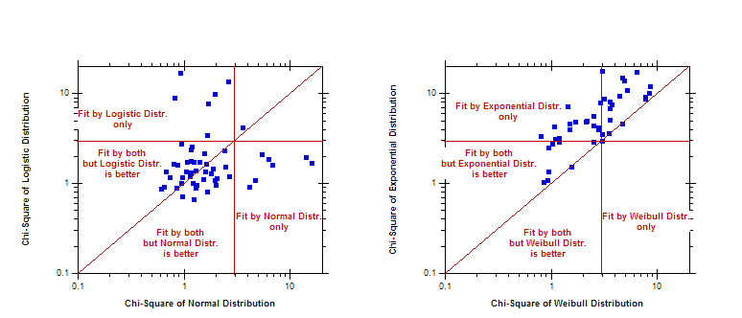
Figure 3. Chi-square comparison for probability density statistical functions used in the study. a). Fit by normal distribution is compared with logistic, and b). Weibull is compared with exponential distribution.

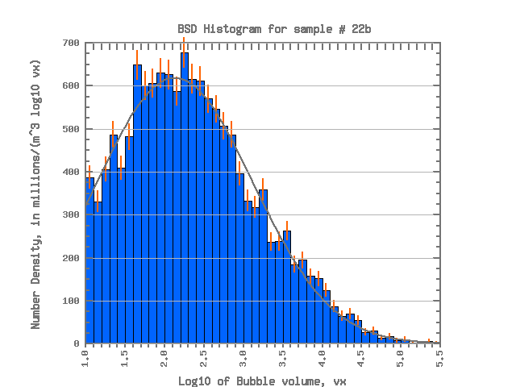
Figure 4. Visualization of good fit near chi-square subjective threshold value of 3. Normal distribution fit on this graph for sample 22b has chi-square value of 2.5 (see Table 1). Measurement standard deviation errors are shown as sticks on top of each histogram bar.

As you can see from Figure 3 normal and logistic distributions are very close one to each other. And quite often it is just a matter of researcher preferences which one to choose since fit error are virtually the same. This fact is indicated on the Figure 3 by a note indicating that actual data could be fit by both function, but one of them with smaller chi-square might be preferable. Note also that most of samples could be approximated by these functions. This might contradict to numbers given in Table 2, but we would like to remind readers about “human” factor in making last call to make a choice of best fit (this was discussed above in the txt for the flowchart on Fig. 1). An opposite situation arises for Weibull and exponential distributions. Very few of them have a good fit (see also Table 2). You can also see that there is no exponential distributions to be better than Weibull which reflects the fact that exponential distribution is just a special case of Weibull with sigma equal to 1 [Proussevitch, this issue #7398] and these samples that lie on the diagonal have this value.

Figure 5 shows a histogram of chi-square values differentiated by distribution type. So you can see that almost all samples have a good fit under chi-square threshold value and these few above it have poor fit and we did not have an alternative to make a better choice.

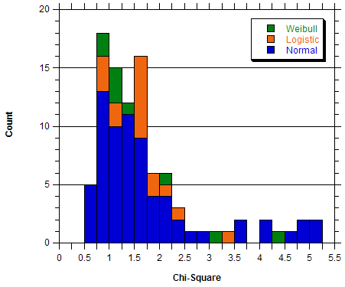

Figure 5. Histogram of chi-square values for functions that has been chosen to be a best fit in Table 1.

5.2. Distribution parameters

For all best fit distribution types we have three common parameters. These are distribution sigma, mode or location (“location” is its another name), and BND. If data is bimodal distributions, then it has two sets of these parameters. These three parameters could be obtained by fitting probability density or exceedance (Figure 1), and they are supposed to match. Indeed, Figure 6 indicates a very good match of the values obtained by the two methods. Keep in mind that the third parameter (BND) can not be obtained from exceedance and is a product of local number density function [Proussevitch, this issue #7398].

Figure 6 also displays histograms of the parameters which indicate quite wide range of sigma and bimodal character of distribution locations.

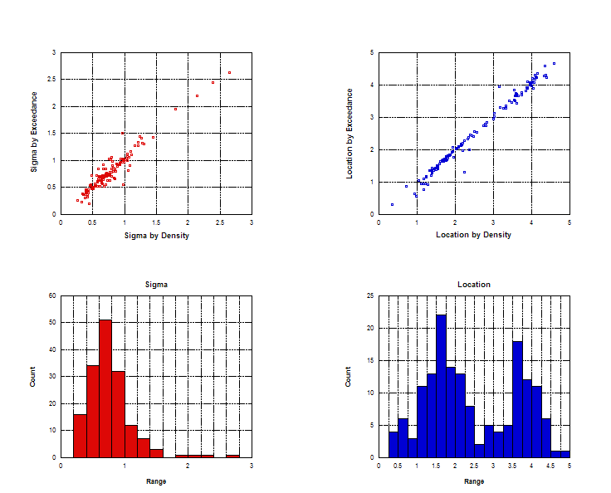
Figure 6. Comparison of sigma (a) and location (b) values obtained by distribution fit from probability density and exceedance. (c) and (d) are histograms of these parameters.

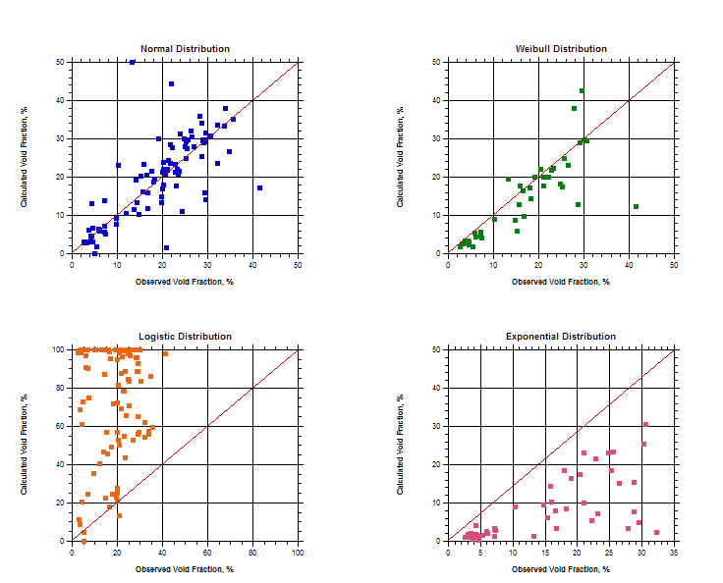

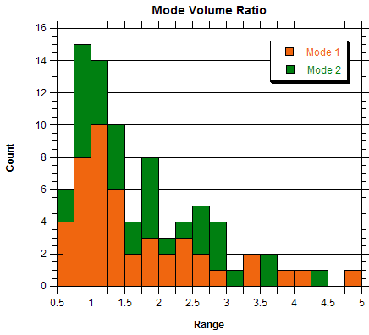

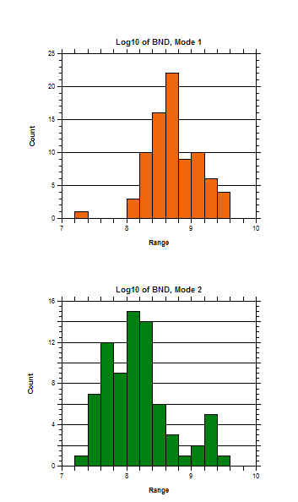

Table 1. Best fit functions of statistical distributions for bubble populations in basalt samples from Colorado Plateau.
Sample | Mode 1 |  |  | Mode 2 |  |  | Mean χ² | Void Fraction, % |  | Method | Distribution
Sample | σ | v | BND, 10⁹  or  Fraction | σ | v | BND, 10⁹  or  Fraction | Mean χ² | Observed | Calculated | Method | Distribution
01b | - | - | - | 1.022 | 1.709 | 0.734 | 2.405 | 6.036 | 5.826 | Density | Normal
01b | - | - | - | 1.013 | 1.721 | 1.000 | 2.107* | - | - | Exceedance | Normal
01t | 0.801 | 1.223 | 0.292 | 0.503 | 3.617 | 0.154 | 1.145 | 13.799 | 11.583 | Density | Normal
01t | 1.057 | 0.948 | 0.738 | 0.484 | 3.667 | 0.262 | 0.467* | - | - | Exceedance | Normal
02b | 1.013 | 1.378 | 1.866 | - | - | - | 3.610 | 5.913 | 6.512 | Density | Normal
02b | 1.012 | 1.369 | 1.000 | - | - | - | 5.147* | - | - | Exceedance | Normal
02t | 0.464 | 1.385 | 1.079 | 0.255 | 2.812 | 0.235 | 1.731 | 7.097 | 24.362 | Density | Logistic
02t | 0.508 | 1.290 | 0.830 | 0.268 | 2.752 | 0.170 | 2.692* | - | - | Exceedance | Logistic
03b | 2.383 | 0.357 | 0.512 | - | - | - | 1.087 | 3.799 | 3.270 | Density | Weibull
03b | 2.451 | 0.299 | 1.000 | - | - | - | 0.555* | - | - | Exceedance | Weibull
03t | 0.495 | 0.714 | 0.793 | 0.424 | 4.441 | 0.029 | 1.615 | 29.266 | 64.845 | Density | Logistic
04b | 1.231 | 0.595 | 0.641 | 0.749 | 3.576 | 0.152 | 0.896 | 23.813 | 21.654 | Density | Normal
04t | - | - | - | 1.163 | 3.950 | 0.113 | 0.852 | 30.224 | 29.602 | Density | Weibull
04t | - | - | - | 1.276 | 3.998 | 1.000 | 0.133* | - | - | Exceedance | Weibull
05b | 0.852 | 0.447 | 0.403 | 0.225 | 3.640 | 0.091 | 1.609 | 9.823 | 99.980 | Density | Logistic
05t | 0.507 | 0.262 | 0.145 | 0.408 | 4.480 | 0.029 | 0.880 | 32.209 | 54.287 | Density | Logistic
06b | 1.284 | 2.479 | 0.105 | 0.436 | 3.650 | 0.052 | 0.862 | 10.298 | 22.954 | Density | Normal
06b | 1.326 | 2.416 | 0.671 | 0.454 | 3.668 | 0.329 | 0.071* | - | - | Exceedance | Normal
06t | 1.237 | 2.494 | 0.170 | 0.412 | 4.360 | 0.034 | 0.611 | 26.466 | 30.567 | Density | Normal
06t | 1.447 | 2.555 | 0.892 | 0.364 | 4.298 | 0.108 | 0.186* | - | - | Exceedance | Normal
07b | 1.105 | 1.678 | 0.384 | - | - | - | 1.071 | 4.089 | 4.590 | Density | Normal
07b | 1.106 | 1.684 | 1.000 | - | - | - | 0.772* | - | - | Exceedance | Normal
07t | 0.984 | 1.811 | 0.311 | 0.421 | 2.793 | 0.205 | 0.740 | 4.304 | 4.576 | Density | Normal
07t | 1.026 | 1.743 | 0.596 | 0.428 | 2.782 | 0.404 | 0.150* | - | - | Exceedance | Normal
08b | 0.769 | 1.034 | 0.202 | - | - | - | 1.142 | 4.663 | 99.895 | Density | Logistic
08b | 0.777 | 1.061 | 1.000 | - | - | - | 0.598* | - | - | Exceedance | Logistic
08t | 0.457 | 1.369 | 0.512 | 0.306 | 3.997 | 0.069 | 1.241 | 19.754 | 22.974 | Density | Logistic
08t | 0.484 | 1.336 | 0.888 | 0.280 | 4.043 | 0.112 | 0.515* | - | - | Exceedance | Logistic
09b | - | - | - | 1.802 | 1.954 | 0.190 | 0.943 | 7.171 | 5.022 | Density | Weibull
09b | - | - | - | 1.957 | 1.776 | 1.000 | 0.462* | - | - | Exceedance | Weibull
09t | 0.238 | 1.246 | 0.396 | 0.729 | 1.573 | 0.476 | 1.638 | 14.196 | 99.946 | Density | Logistic
10b | 0.995 | 1.327 | 0.974 | - | - | - | 2.855 | 3.283 | 2.853 | Density | Normal
10b | 0.967 | 1.361 | 1.000 | - | - | - | 3.905* | - | - | Exceedance | Normal
10t | 0.794 | 1.166 | 0.352 | 0.507 | 3.901 | 0.123 | 1.188 | 19.903 | 16.825 | Density | Normal
10t | 0.840 | 1.090 | 0.753 | 0.506 | 3.904 | 0.247 | 0.350* | - | - | Exceedance | Normal
11b | 0.597 | 1.102 | 0.443 | 0.429 | 3.563 | 0.118 | 1.867 | 20.157 | 94.885 | Density | Logistic
11b | 0.702 | 0.959 | 0.834 | 0.437 | 3.663 | 0.166 | 0.858* | - | - | Exceedance | Logistic
11t | 0.535 | 1.492 | 2.811 | - | - | - | 2.085 | 16.804 | 95.440 | Density | Logistic
11t | 0.567 | 1.394 | 1.000 | - | - | - | 5.442* | - | - | Exceedance | Logistic
12b | 0.406 | 1.545 | 2.008 | - | - | - | 3.406 | 3.510 | 8.527 | Density | Logistic
12b | 0.448 | 1.422 | 1.000 | - | - | - | 14.781* | - | - | Exceedance | Logistic
12t | 0.387 | 1.400 | 2.167 | - | - | - | 2.366 | 5.407 | 4.419 | Density | Logistic
12t | 0.414 | 1.314 | 1.000 | - | - | - | 10.404* | - | - | Exceedance | Logistic
13b | 0.925 | 1.766 | 0.542 | - | - | - | 1.659 | 4.650 | 3.057 | Density | Normal
13b | 0.921 | 1.78 | 1.000 | - | - | - | 1.240* | - | - | Exceedance | Normal
13t | 1.300 | 1.791 | 0.198 | 0.482 | 4.077 | 0.093 | 0.799 | 21.332 | 24.392 | Density | Normal
13t | 1.300 | 1.797 | 0.680 | 0.475 | 4.084 | 0.320 | 0.094* | - | - | Exceedance | Normal
14b | - | - | - | 1.048 | 2.176 | 0.109 | 0.742 | 2.528 | 3.005 | Density | Normal
14b | - | - | - | 1.073 | 2.155 | 1.000 | 0.173* | - | - | Exceedance | Normal
14t | 0.758 | 1.613 | 0.271 | 0.575 | 3.415 | 0.232 | 1.666 | 14.338 | 13.368 | Density | Normal
14t | 1.035 | 1.630 | 0.666 | 0.530 | 3.517 | 0.334 | 0.595* | - | - | Exceedance | Normal
15b | - | - | - | 1.454 | 1.927 | 2.055 | 1.424 | 18.205 | 14.444 | Density | Weibull
15b | - | - | - | 1.434 | 1.951 | 1.000 | 1.277* | - | - | Exceedance | Weibull
15t | 0.670 | 1.184 | 0.222 | 0.866 | 3.976 | 0.060 | 1.326 | 28.938 | 29.832 | Density | Normal
15t | 0.916 | 0.765 | 0.868 | 0.801 | 4.083 | 0.132 | 0.741* | - | - | Exceedance | Normal
17b | - | - | - | 0.663 | 2.833 | 2.185 | 4.375 | 17.944 | 17.181 | Density | Weibull
17b | - | - | - | 0.643 | 2.834 | 1.000 | 5.022* | - | - | Exceedance | Weibull
17t | - | - | - | 1.067 | 2.738 | 1.841 | 3.034 | 25.642 | 24.745 | Density | Weibull
17t | - | - | - | 1.06 | 2.743 | 1.000 | 2.467* | - | - | Exceedance | Weibull
18b | 2.646 | 0.728 | 0.508 | - | - | - | 1.070 | 13.260 | 19.379 | Density | Weibull
18b | 2.624 | 0.864 | 1.000 | - | - | - | 0.339* | - | - | Exceedance | Weibull
18t | 0.660 | 1.185 | 1.388 | 0.976 | 3.153 | 0.114 | 2.648 | 23.138 | 17.698 | Density | Normal
18t | 0.844 | 0.961 | 0.972 | 0.548 | 3.952 | 0.028 | 6.318* | - | - | Exceedance | Normal
19b | 0.563 | 1.183 | 0.569 | 0.768 | 3.545 | 0.058 | 1.692 | 9.765 | 9.210 | Density | Normal
19b | 0.726 | 0.936 | 0.944 | 0.636 | 3.842 | 0.056 | 3.456* | - | - |  | Normal
19t | 0.587 | 1.233 | 0.628 | 0.847 | 4.016 | 0.038 | 1.521 | 17.580 | 21.433 | Density | Normal
19t | 0.657 | 1.154 | 0.953 | 0.667 | 4.206 | 0.047 | 3.073* | - | - | Exceedance | Normal
20b | 0.612 | 0.906 | 0.621 | 0.924 | 3.713 | 0.024 | 2.042 | 24.294 | 11.098 | Density | Normal
20t | 0.860 | 0.410 | 2.842 | 0.780 | 4.203 | 0.037 | 5.194 | 20.139 | 23.720 | Density | Normal
21b | 0.813 | 1.441 | 0.371 | 0.613 | 4.123 | 0.030 | 1.461 | 12.030 | 10.566 | Density | Normal
21b | 0.904 | 1.353 | 0.936 | 0.516 | 4.221 | 0.064 | 1.874* | - | - | Exceedance | Normal
21t | 0.386 | 1.546 | 1.309 | 0.322 | 4.112 | 0.080 | 1.731 | 20.164 | 27.565 | Density | Logistic
21t | 0.455 | 1.402 | 0.963 | 0.227 | 4.261 | 0.037 | 6.837* | - | - | Exceedance | Logistic
22b | - | - | - | 0.972 | 2.164 | 1.504 | 2.479 | 21.037 | 21.692 | Density | Normal
22b | - | - | - | 1.010 | 2.126 | 1.000 | 1.909* | - | - | Exceedance | Normal
22t | 1.546 | 0.657 | 1.039 | 0.573 | 3.686 | 0.166 | 1.245 | 26.204 | 32.146 | Density | Normal
23b | 0.654 | 1.395 | 0.570 | 0.647 | 4.390 | 0.079 | 1.504 | 33.830 | 37.819 | Density | Normal
23b | 0.570 | 1.438 | 0.856 | 0.726 | 4.233 | 0.144 | 1.536* | - | - | Exceedance | Normal
23t | 0.786 | 0.973 | 0.810 | 0.706 | 4.161 | 0.069 | 1.489 | 27.005 | 27.908 | Density | Normal
23t | 1.011 | 0.568 | 0.955 | 0.558 | 4.349 | 0.045 | 3.576* | - | - | Exceedance | Normal
24b | - | - | - | 2.142 | 2.398 | 0.222 | 1.204 | 27.852 | 37.864 | Density | Weibull
24b | - | - | - | 2.196 | 2.469 | 1.000 | 0.836* | - | - | Exceedance | Weibull
24t | 0.819 | 1.349 | 0.379 | 0.639 | 4.087 | 0.071 | 1.354 | 19.987 | 21.182 | Density | Normal
24t | 0.857 | 1.362 | 0.852 | 0.589 | 4.167 | 0.148 | 1.169* | - | - | Exceedance | Normal
25b | 0.325 | 1.030 | 0.414 | - | - | - | 1.644 | 5.111 | 0.151 | Density | Logistic
25t | 0.451 | 1.282 | 1.243 | - | - | - | 1.582 | 20.877 | 13.446 | Density | Logistic
25t | 0.534 | 0.935 | 1.000 | - | - | - | 9.242* | - | - | Exceedance | Logistic
26b | 0.886 | 1.246 | 2.122 | - | - | - | 4.831 | 3.026 | 2.989 | Density | Normal
26b | 0.922 | 1.166 | 1.000 | - | - | - | 12.158* | - | - | Exceedance | Normal
26t | 0.946 | 1.371 | 1.418 | - | - | - | 1.868 | 4.194 | 3.559 | Density | Normal
26t | 1.024 | 1.204 | 1.000 | - | - | - | 6.025* | - | - | Exceedance | Normal
27b | 0.882 | 1.782 | 1.110 | - | - | - | 1.631 | 7.384 | 5.147 | Density | Normal
27b | 0.929 | 1.702 | 1.000 | - | - | - | 3.602* | - | - | Exceedance | Normal
27t | 1.216 | 2.572 | 1.375 | - | - | - | 2.143 | 19.049 | 19.871 | Density | Weibull
27t | 1.269 | 2.530 | 1.000 | - | - | - | 3.584* | - | - | Exceedance | Weibull
28b | 0.790 | 1.546 | 0.350 | 0.319 | 3.526 | 0.208 | 0.915 | 29.658 | 99.980 | Density | Logistic
28t | 0.772 | 2.235 | 0.970 | 0.776 | 4.838 | 0.005 | 1.960 | 15.326 | 20.301 | Density | Normal
29b | 0.963 | 1.654 | 1.412 | - | - | - | 1.830 | 7.195 | 7.099 | Density | Normal
29b | 0.963 | 1.651 | 1.000 | - | - | - | 1.833* | - | - | Exceedance | Normal
29t | 0.750 | 2.170 | 2.832 | - | - | - | 4.127 | 15.752 | 16.060 | Density | Normal
29t | 0.760 | 2.163 | 1.000 | - | - | - | 6.484* | - | - | Exceedance | Normal
30b | 0.864 | 0.527 | 0.579 | 0.848 | 2.872 | 0.055 | 0.957 | 2.565 | 2.909 | Density | Normal
30t | 0.398 | 0.598 | 0.186 | 1.477 | 1.600 | 0.114 | 1.071 | 4.263 | 13.112 | Density | Normal
31b | 0.344 | 1.539 | 0.436 | 0.357 | 3.329 | 0.245 | 1.759 | 19.831 | 21.114 | Density | Logistic
31b | 0.390 | 1.504 | 0.667 | 0.367 | 3.353 | 0.333 | 1.358* | - | - | Exceedance | Logistic
31t | 0.671 | 1.815 | 0.170 | 0.643 | 3.902 | 0.202 | 0.899 | 33.773 | 33.313 | Density | Normal
31t | 0.717 | 1.819 | 0.472 | 0.629 | 3.926 | 0.528 | 0.099* | - | - | Exceedance | Normal
32b | - | - | - | 0.929 | 3.016 | 0.392 | 1.170 | 25.243 | 29.171 | Density | Normal
32b | - | - | - | 0.926 | 3.023 | 1.000 | 0.463* | - | - | Exceedance | Normal
32t | - | - | - | 0.891 | 3.271 | 0.273 | 0.957 | 24.888 | 30.101 | Density | Normal
32t | - | - | - | 0.897 | 3.268 | 1.000 | 0.357* | - | - | Exceedance | Normal
33b | 1.218 | 2.205 | 0.282 | 0.375 | 3.995 | 0.044 | 0.967 | 15.927 | 23.209 | Density | Normal
33b | 1.330 | 2.209 | 0.894 | 0.304 | 3.960 | 0.106 | 0.359* | - | - | Exceedance | Normal
33t | 0.476 | 1.530 | 0.624 | 0.827 | 3.026 | 0.558 | 1.516 | 25.366 | 27.450 | Density | Normal
33t | 0.554 | 1.514 | 0.588 | 0.795 | 3.117 | 0.412 | 1.360* | - | - | Exceedance | Normal
34b | 0.801 | 2.340 | 1.433 | 0.434 | 3.540 | 0.213 | 2.122 | 22.877 | 23.235 | Density | Normal
34b | 0.839 | 2.374 | 0.904 | 0.406 | 3.531 | 0.096 | 0.596* | - | - | Exceedance | Normal
34t | 1.101 | 2.248 | 0.408 | 0.377 | 4.596 | 0.046 | 1.292 | 29.534 | 31.523 | Density | Normal
34t | 1.174 | 2.269 | 0.920 | 0.309 | 4.664 | 0.080 | 0.387* | - | - | Exceedance | Normal
35b | 0.420 | 1.475 | 0.023 | 0.686 | 3.475 | 0.266 | 2.061 | 21.055 | 22.126 | Density | Normal
35b | 0.322 | 1.424 | 0.063 | 0.715 | 3.468 | 0.937 | 1.171* | - | - | Exceedance | Normal
35t | 0.679 | 1.840 | 0.242 | 0.627 | 3.881 | 0.183 | 1.292 | 29.275 | 29.235 | Density | Normal
35t | 0.691 | 1.848 | 0.576 | 0.632 | 3.912 | 0.424 | 0.198* | - | - | Exceedance | Normal
36b | 0.574 | 1.551 | 0.188 | 0.722 | 3.324 | 0.323 | 1.150 | 20.449 | 21.949 | Density | Normal
36b | 0.603 | 1.485 | 0.359 | 0.755 | 3.292 | 0.641 | 0.148* | - | - | Exceedance | Normal
36t | 0.873 | 2.436 | 0.477 | 0.591 | 3.576 | 0.352 | 1.310 | 30.584 | 30.844 | Density | Normal
36t | 0.932 | 2.423 | 0.561 | 0.638 | 3.522 | 0.439 | 0.294* | - | - | Exceedance | Normal
37b | 0.942 | 2.021 | 0.805 | 0.497 | 3.536 | 0.467 | 1.252 | 29.114 | 29.054 | Density | Normal
37b | 0.970 | 2.015 | 0.642 | 0.497 | 3.541 | 0.358 | 0.222* | - | - | Exceedance | Normal
37t | 0.709 | 1.530 | 0.397 | 0.77 | 3.581 | 0.270 | 0.913 | 28.691 | 34.088 | Density | Normal
37t | 0.852 | 1.500 | 0.661 | 0.733 | 3.672 | 0.339 | 0.543* | - | - | Exceedance | Normal
38b | 1.08 | 2.371 | 0.309 | 0.489 | 3.604 | 0.055 | 0.775 | 41.422 | 17.153 | Density | Normal
38b | 0.905 | 2.004 | 0.599 | 0.719 | 3.436 | 0.401 | 0.063* | - | - | Exceedance | Normal
38t | 0.704 | 1.680 | 0.913 | 0.642 | 3.876 | 0.212 | 1.327 | 32.281 | 33.563 | Density | Normal
38t | 0.727 | 1.672 | 0.822 | 0.619 | 3.909 | 0.178 | 0.806* | - | - | Exceedance | Normal
39b | 0.641 | 2.089 | 3.828 | 0.439 | 4.019 | 0.148 | 3.720 | 29.638 | 29.050 | Density | Normal
39b | 0.663 | 2.097 | 0.973 | 0.206 | 4.089 | 0.027 | 1.355* | - | - | Exceedance | Normal
39t | 0.714 | 1.590 | 0.727 | 0.727 | 3.967 | 0.115 | 1.694 | 23.884 | 31.315 | Density | Normal
39t | 0.771 | 1.560 | 0.884 | 0.629 | 4.074 | 0.116 | 0.807* | - | - | Exceedance | Normal
40b | - | - | - | 0.912 | 2.327 | 2.109 | 5.173 | 28.848 | 29.447 | Density | Normal
40b | - | - | - | 0.929 | 2.327 | 1.000 | 4.883* | - | - | Exceedance | Normal
40t | 0.815 | 0.941 | 0.582 | 0.839 | 4.092 | 0.044 | 0.828 | 34.807 | 26.651 | Density | Normal
40t | 0.982 | 0.652 | 0.953 | 0.672 | 4.308 | 0.047 | 1.212* | - | - | Exceedance | Normal
41b | 0.726 | 1.864 | 0.450 | 0.712 | 3.734 | 0.119 | 1.292 | 22.765 | 21.208 | Density | Normal
41b | 0.725 | 1.843 | 0.777 | 0.726 | 3.699 | 0.223 | 0.623* | - | - | Exceedance | Normal
41t | 0.569 | 1.844 | 0.621 | 1.043 | 3.168 | 0.203 | 1.592 | 28.248 | 35.968 | Density | Normal
41t | 0.619 | 1.817 | 0.794 | 1.000 | 3.315 | 0.206 | 1.069* | - | - | Exceedance | Normal
42b | - | - | - | 1.048 | 1.765 | 2.334 | 4.202 | 16.540 | 20.454 | Density | Normal
42b | - | - | - | 1.130 | 1.671 | 1.000 | 2.537* | - | - | Exceedance | Normal
42t | - | - | - | 0.708 | 2.083 | 11.500 | 15.850 | 35.575 | 35.065 | Density | Normal
42t | - | - | - | 0.713 | 2.080 | 1.000 | 9.294* | - | - | Exceedance | Normal
44b | 0.626 | 1.717 | 1.810 | 0.590 | 4.047 | 0.056 | 2.115 | 16.675 | 15.905 | Density | Normal
44b | 0.623 | 1.709 | 0.963 | 0.845 | 3.891 | 0.037 | 2.568* | - | - | Exceedance | Normal
44t | 0.396 | 1.692 | 0.378 | 0.398 | 4.019 | 0.069 | 0.991 | 23.326 | 43.601 | Density | Logistic
44t | 0.431 | 1.646 | 0.862 | 0.364 | 4.064 | 0.138 | 0.886* | - | - | Exceedance | Logistic
45b | 0.616 | 1.524 | 0.246 | 0.774 | 3.613 | 0.147 | 1.214 | 21.704 | 23.457 | Density | Normal
45b | 0.711 | 1.503 | 0.676 | 0.717 | 3.725 | 0.324 | 0.428* | - | - | Exceedance | Normal
45t | 0.669 | 1.718 | 0.461 | 0.854 | 3.747 | 0.098 | 1.290 | 21.655 | 28.370 | Density | Normal
45t | 0.684 | 1.718 | 0.831 | 0.849 | 3.770 | 0.169 | 0.613* | - | - | Exceedance | Normal
46b | 0.767 | 1.682 | 0.380 | 0.648 | 3.839 | 0.116 | 1.171 | 20.562 | 20.661 | Density | Normal
46b | 0.760 | 1.677 | 0.755 | 0.671 | 3.828 | 0.245 | 0.344* | - | - | Exceedance | Normal
46t | 0.707 | 1.762 | 0.425 | 0.793 | 3.593 | 0.150 | 0.682 | 25.296 | 24.821 | Density | Normal
46t | 0.752 | 1.790 | 0.783 | 0.702 | 3.750 | 0.217 | 0.503* | - | - | Exceedance | Normal
47b | 0.612 | 1.451 | 0.320 | 1.059 | 3.889 | 0.051 | 1.240 | 21.862 | 44.329 | Density | Normal
47b | 0.687 | 1.414 | 0.897 | 0.810 | 4.112 | 0.103 | 0.929* | - | - | Exceedance | Normal
47t | 0.790 | 2.042 | 0.668 | 0.475 | 4.324 | 0.056 | 1.812 | 23.420 | 20.671 | Density | Normal
47t | 0.785 | 2.041 | 0.915 | 0.544 | 4.288 | 0.085 | 0.425* | - | - | Exceedance | Normal
48b | - | - | - | 0.713 | 1.917 | 3.534 | 4.794 | 14.734 | 10.367 | Density | Normal
48b | - | - | - | 0.729 | 1.911 | 1.000 | 4.940* | - | - | Exceedance | Normal
48t | 0.550 | 1.646 | 0.352 | 1.265 | 2.203 | 0.140 | 0.921 | 29.682 | 14.070 | Density | Normal
48t | 0.532 | 1.655 | 0.640 | 1.409 | 1.979 | 0.360 | 0.357* | - | - | Exceedance | Normal
49b | 0.977 | 2.160 | 0.176 | 0.713 | 3.989 | 0.063 | 0.652 | 23.158 | 21.716 | Density | Normal
49b | 1.037 | 2.178 | 0.760 | 0.712 | 4.026 | 0.240 | 0.063* | - | - | Exceedance | Normal
49t | 0.529 | 1.734 | 0.105 | 1.030 | 2.999 | 0.222 | 0.972 | 22.205 | 27.580 | Density | Normal
49t | 0.528 | 1.699 | 0.305 | 1.044 | 2.939 | 0.695 | 0.171* | - | - | Exceedance | Normal
50b | 0.634 | 1.942 | 2.423 | 0.967 | 2.247 | 1.491 | 4.661 | 24.942 | 27.915 | Density | Normal
50b | 0.647 | 2.067 | 0.603 | 1.500 | 1.317 | 0.397 | 2.627* | - | - | Exceedance | Normal
50t | 0.933 | 2.351 | 0.613 | 0.673 | 4.348 | 0.026 | 0.951 | 28.707 | 25.476 | Density | Normal
50t | 0.950 | 2.373 | 0.971 | 0.520 | 4.576 | 0.029 | 0.286* | - | - | Exceedance | Normal
* Chi-Square is not adjusted for exceedance rescaling, and so not reliable. 100 sample points were used for function fit.
Table 2. Graphs of bubble distributions presented in Table 1.
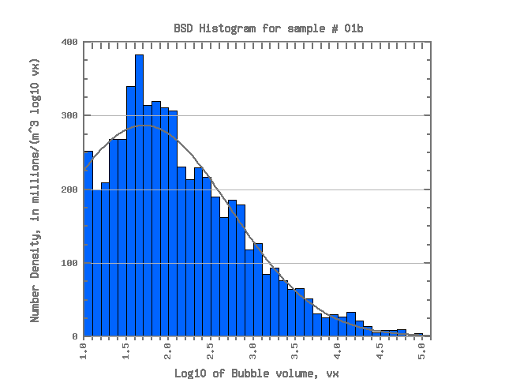  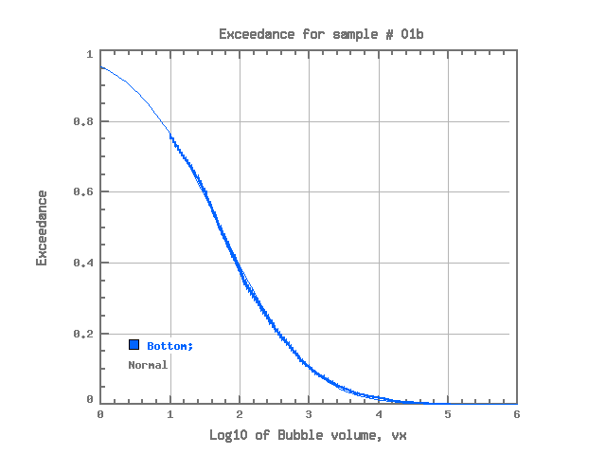  01b (Normal) | 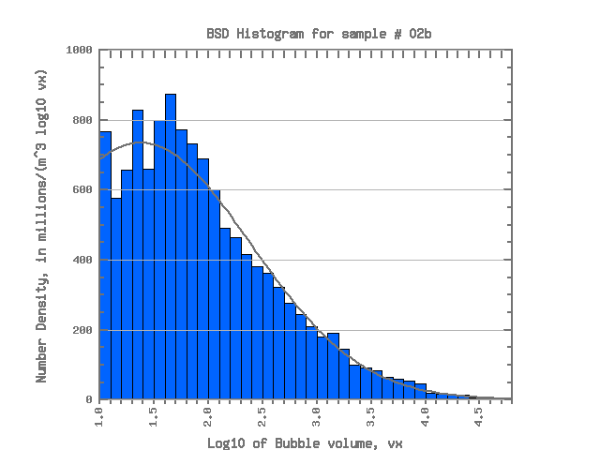  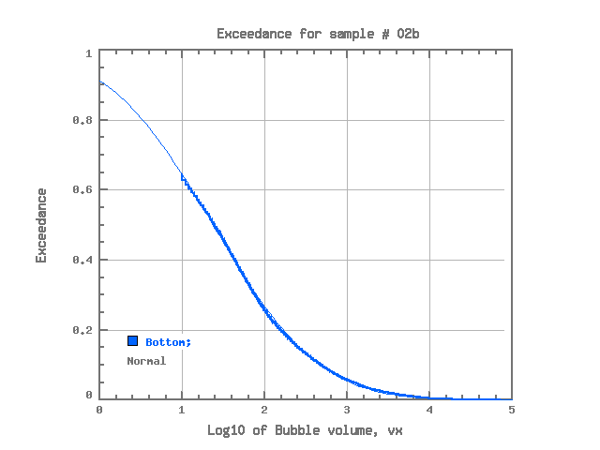  02b (Normal) | 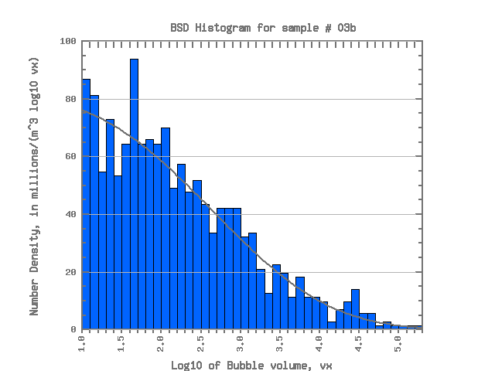  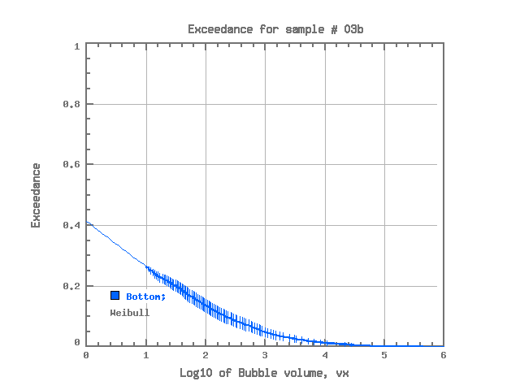  03b (Weibull) | 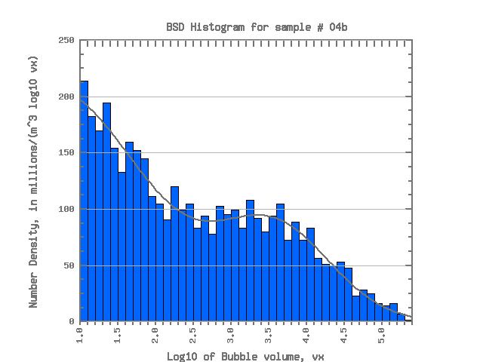  04b (Normal)
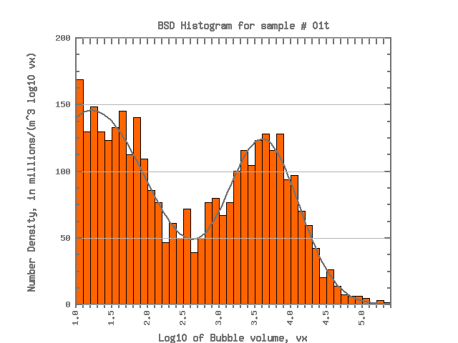  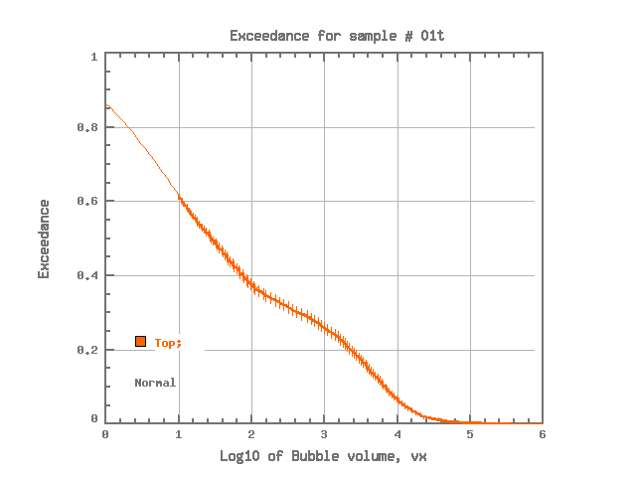  01t (Normal) | 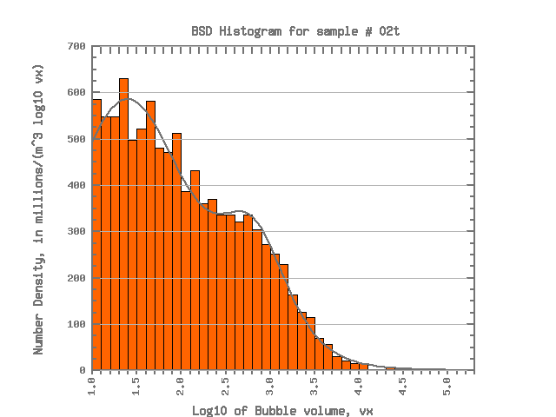  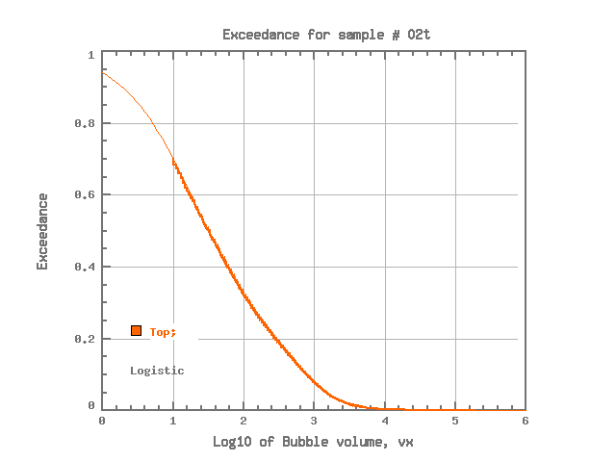  02t (Logistic) | 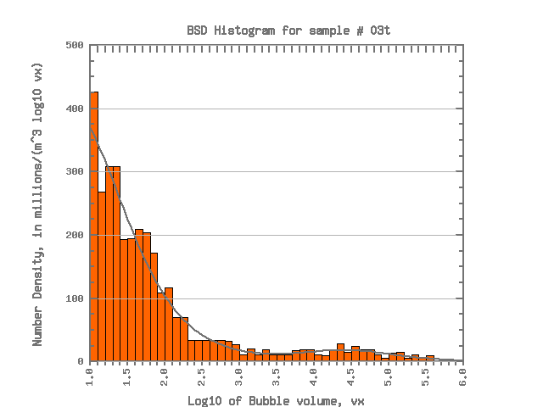  03t (Logistic) | 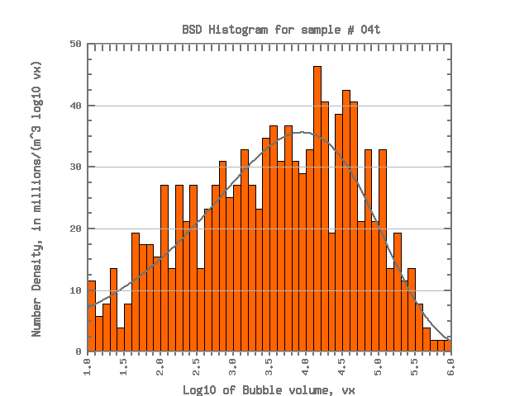  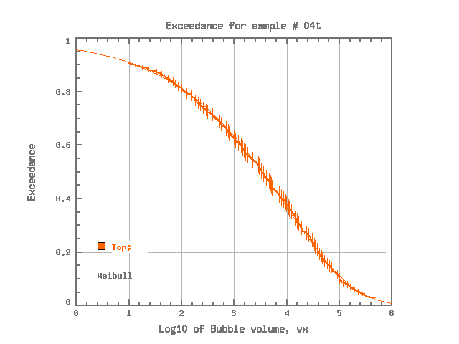  04t (Weibull)
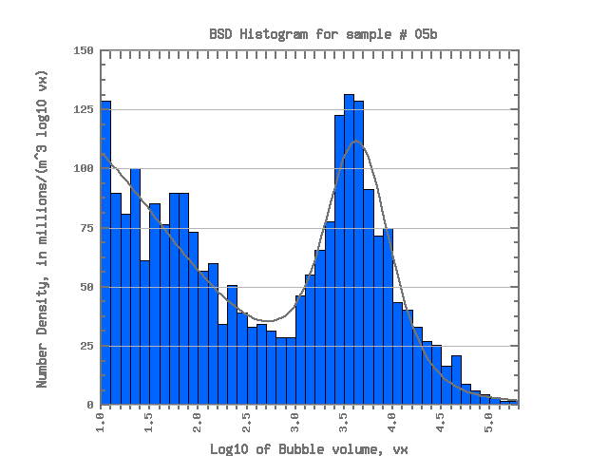  05b (Logistic) | 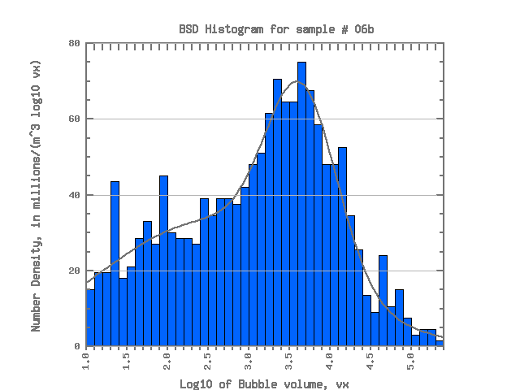  06b (Normal) | 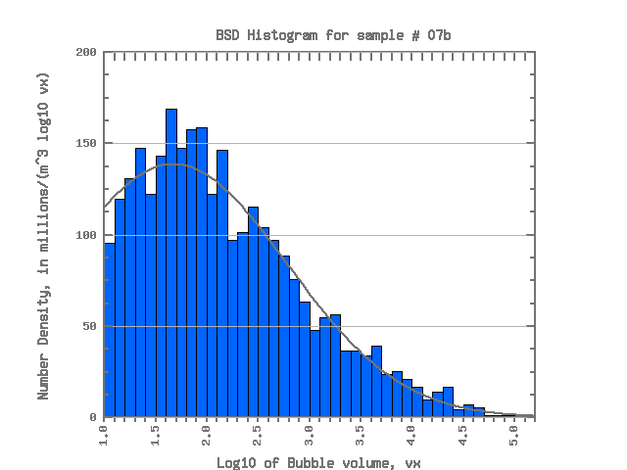  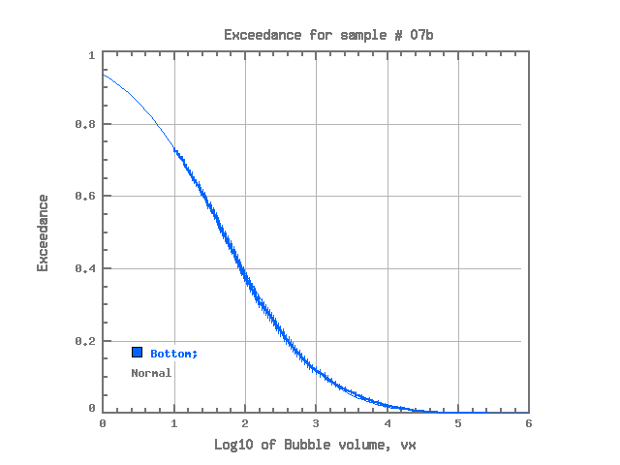  07b (Normal) | 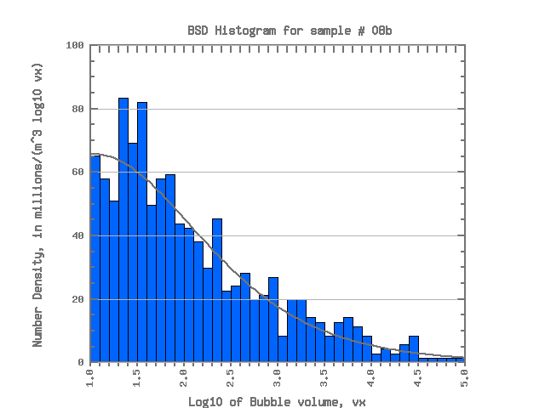  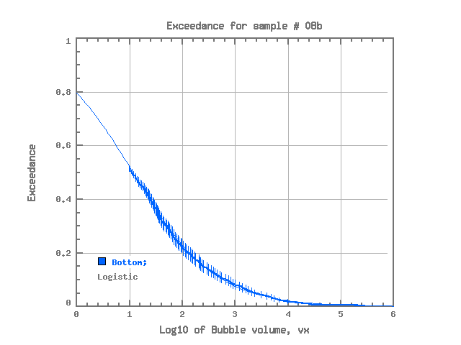  08b (Logistic)
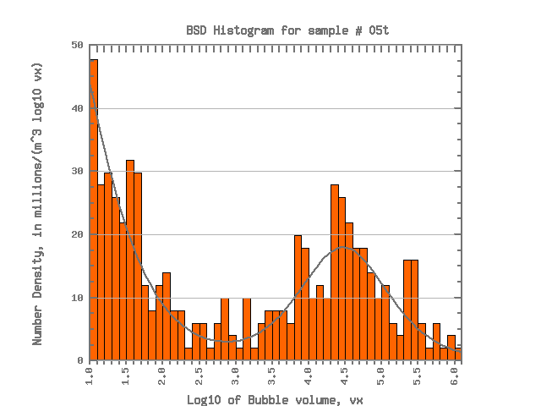  05t (Logistic) | 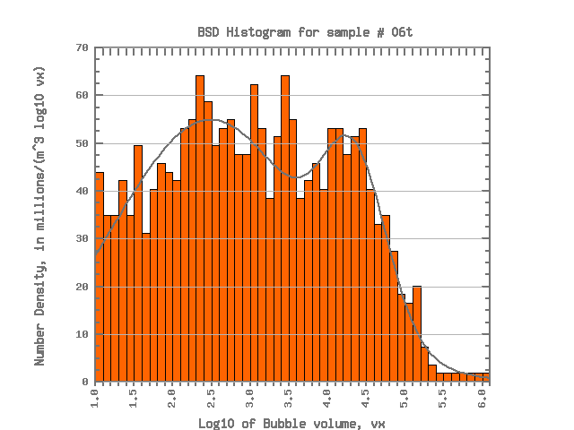  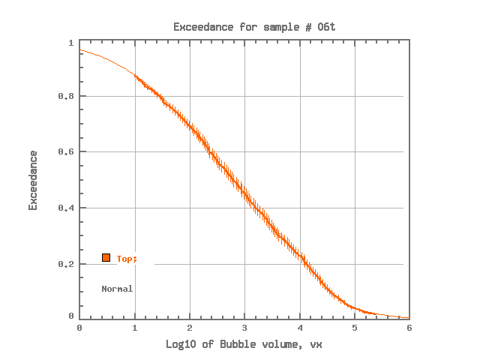  06t (Normal) | 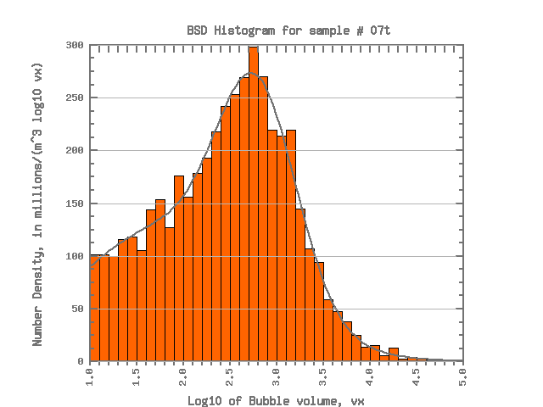  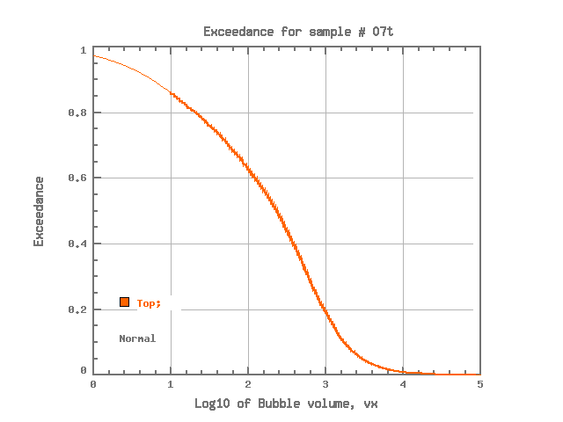  07t (Normal) | 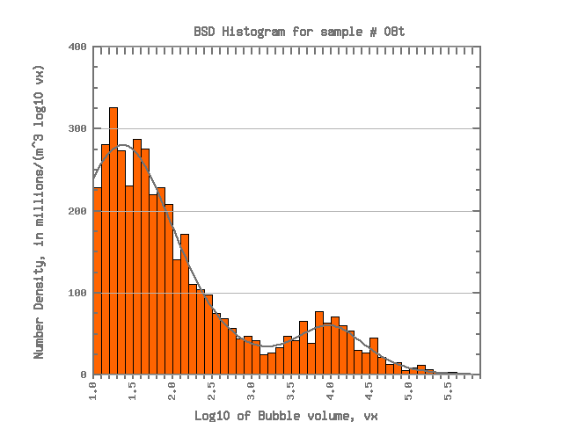  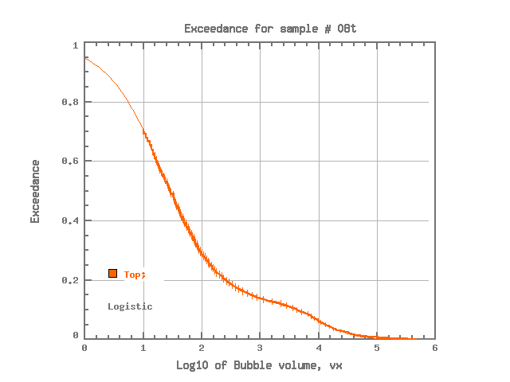  08t (Logistic)
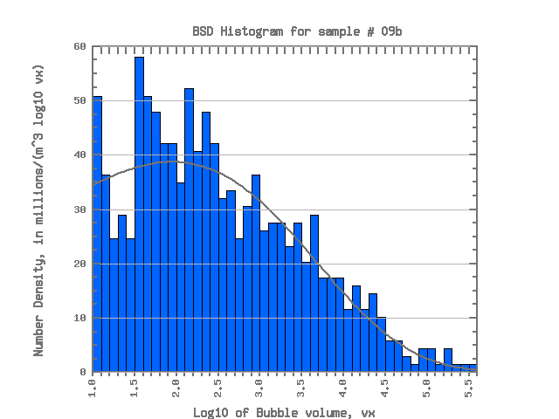  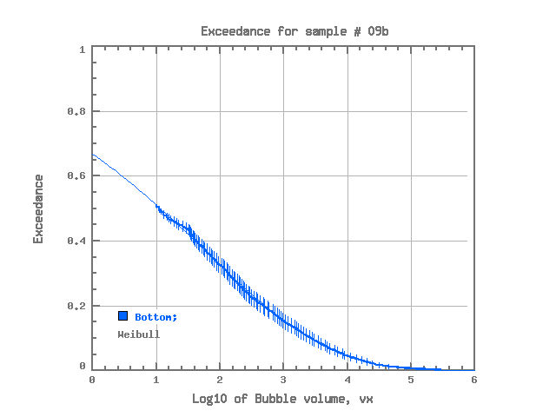  09b (Weibull) | 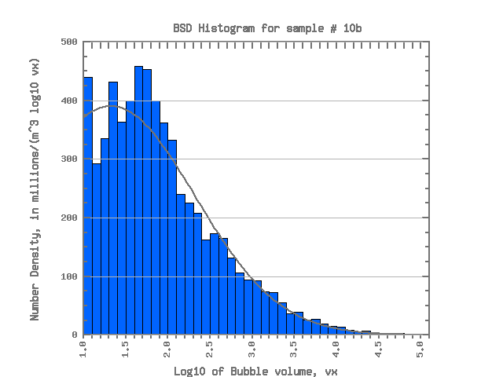  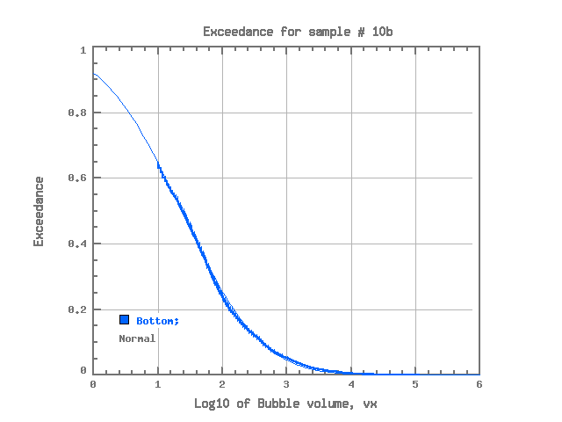  10b (Normal) | 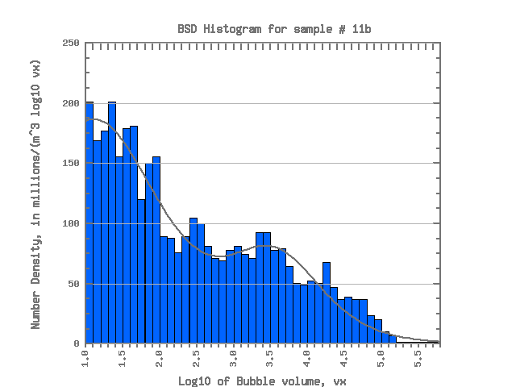  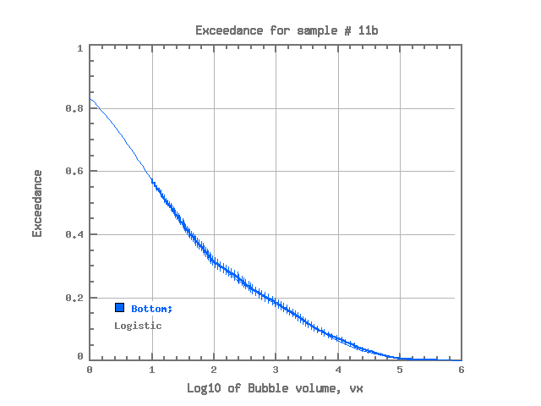  11b (Logistic) | 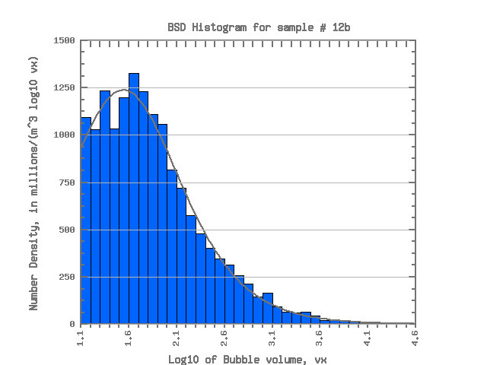  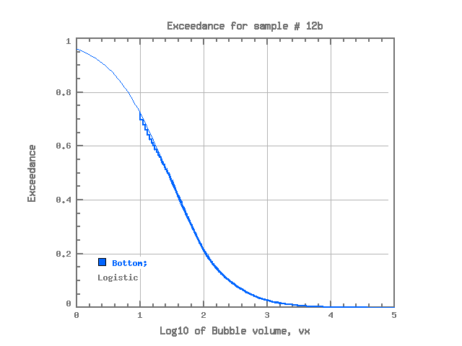  12b (Logistic)
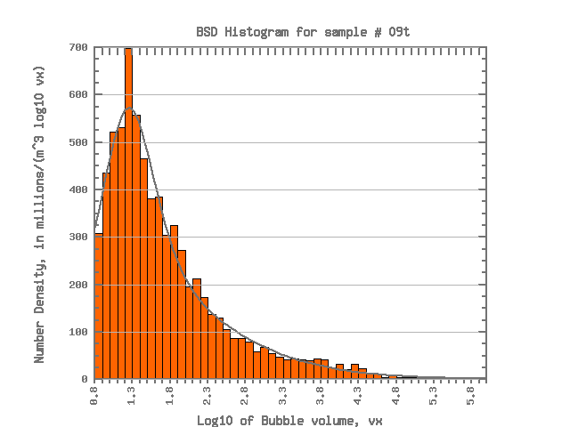  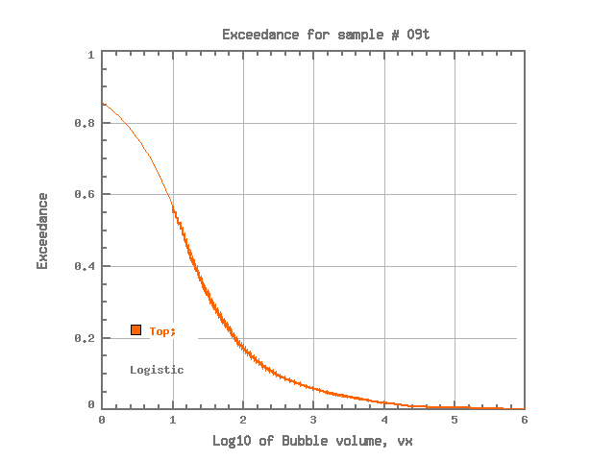  09t (Logistic) | 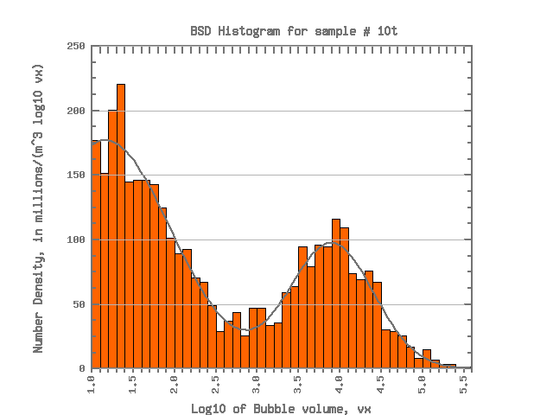  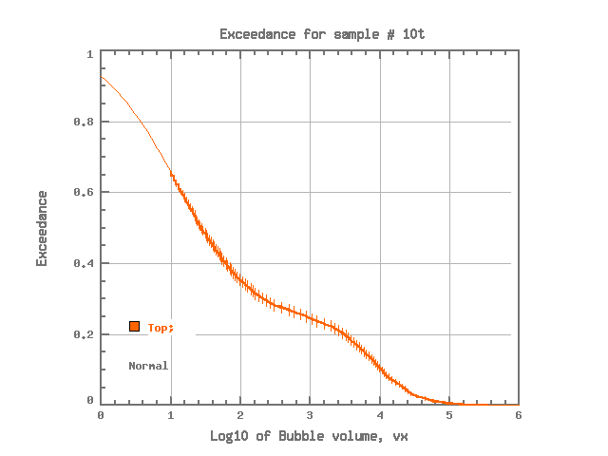  10t (Normal) | 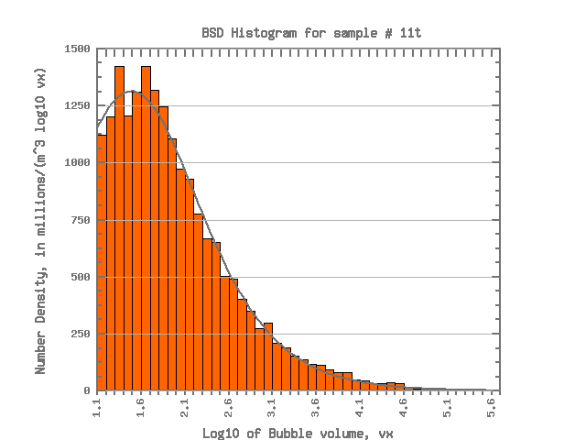  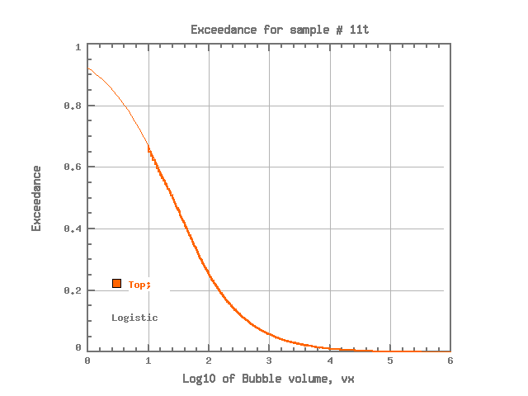  11t (Logistic) | 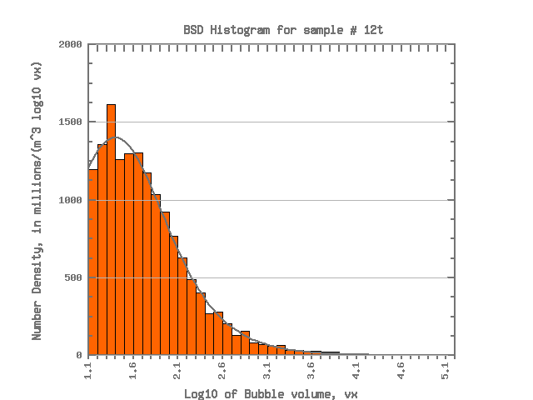  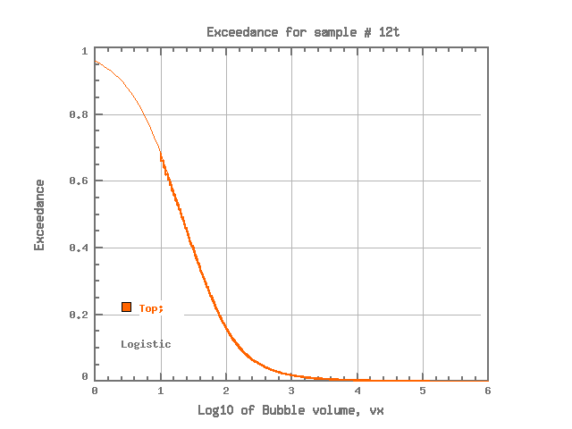  12t (Logistic)
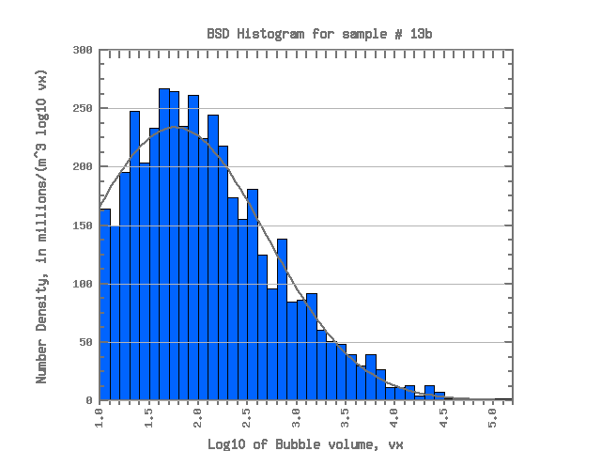  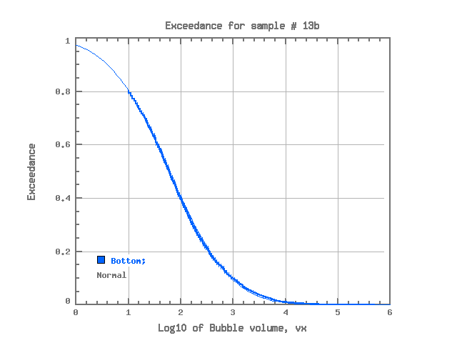  13b (Normal) | 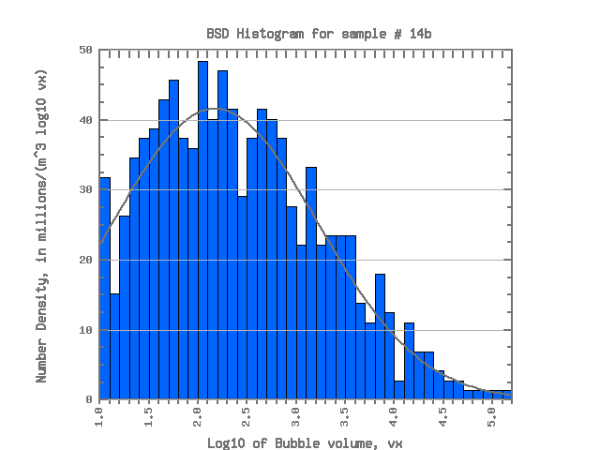  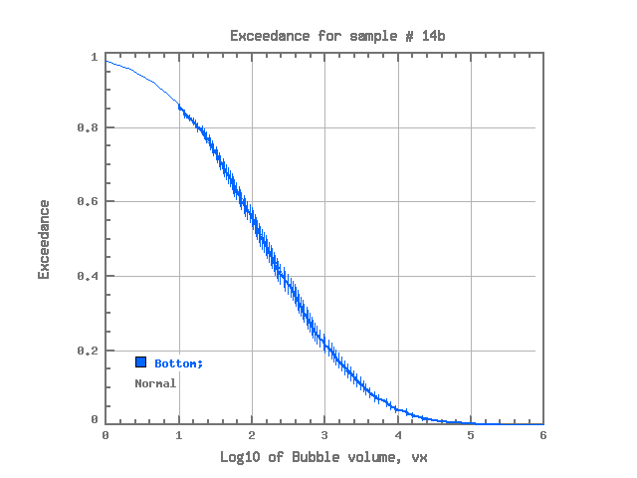  14b (Normal) | 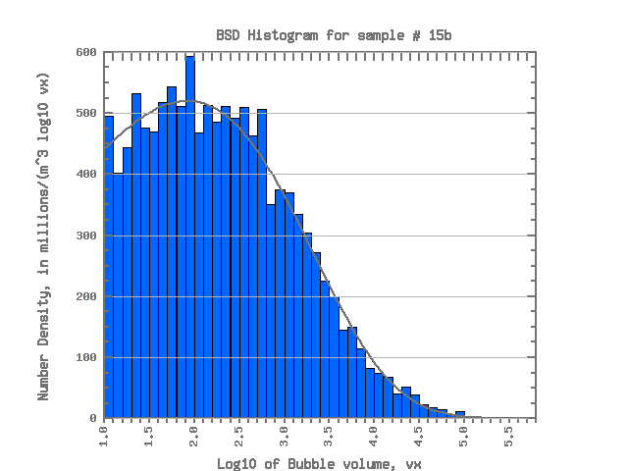  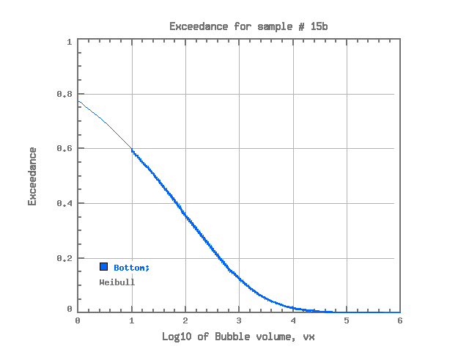  15b (Weibull) | 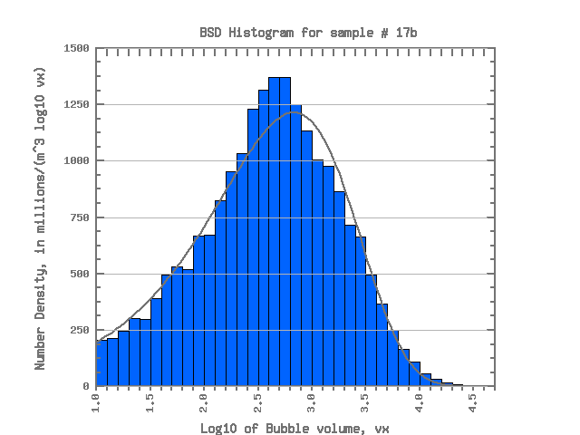  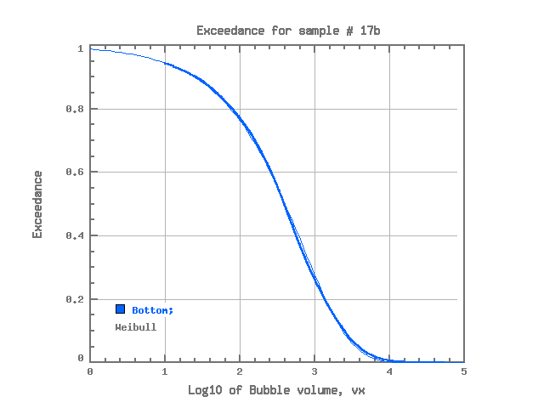  17b (Weibull)
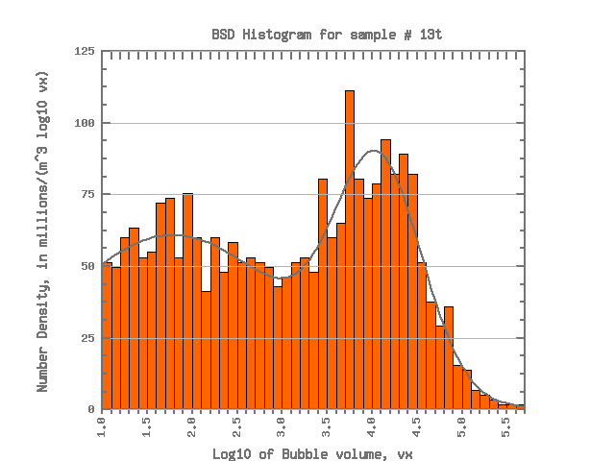  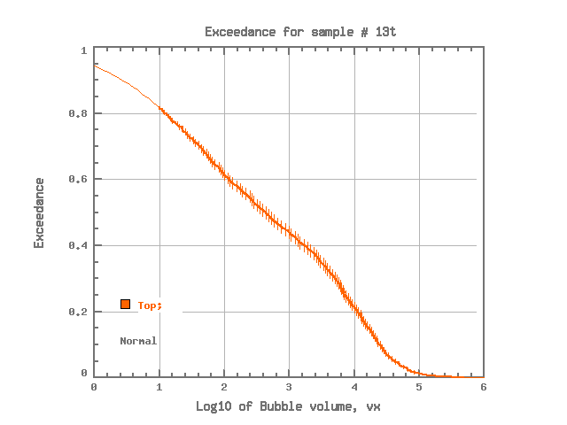  13t (Normal) | 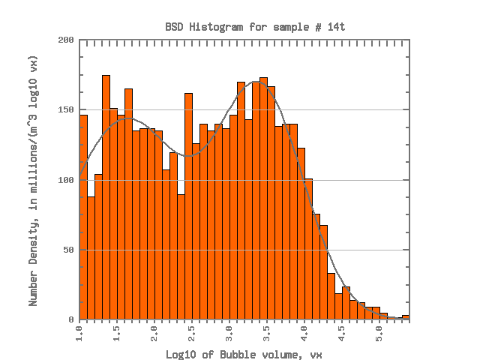  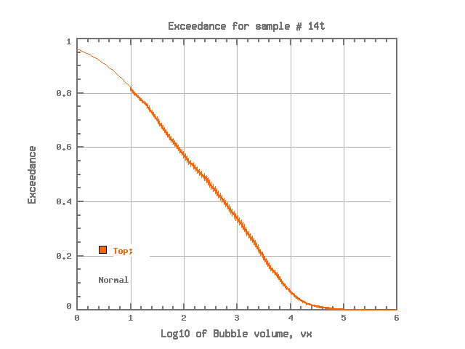  14t (Normal) | 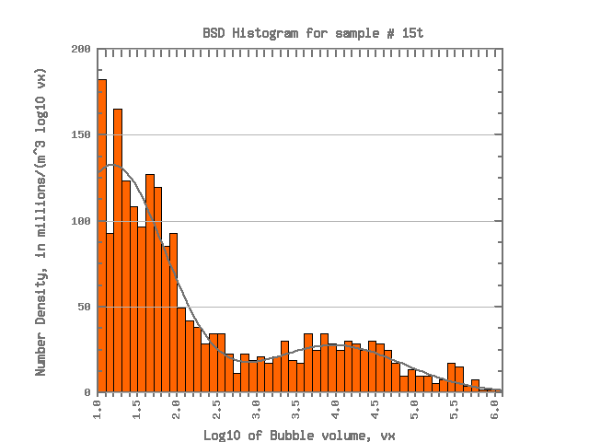  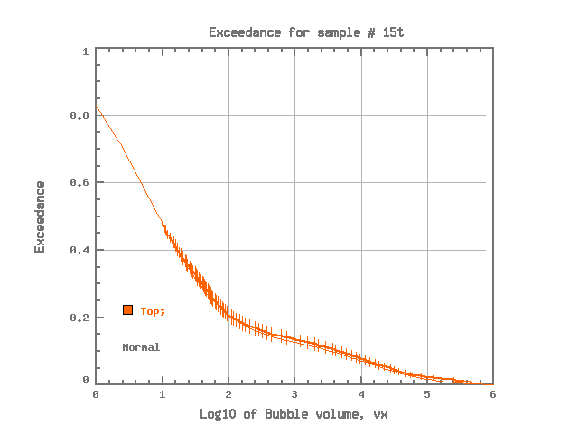  15t (Normal) | 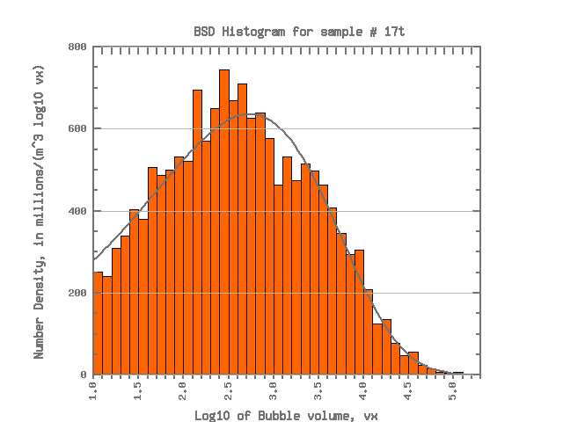  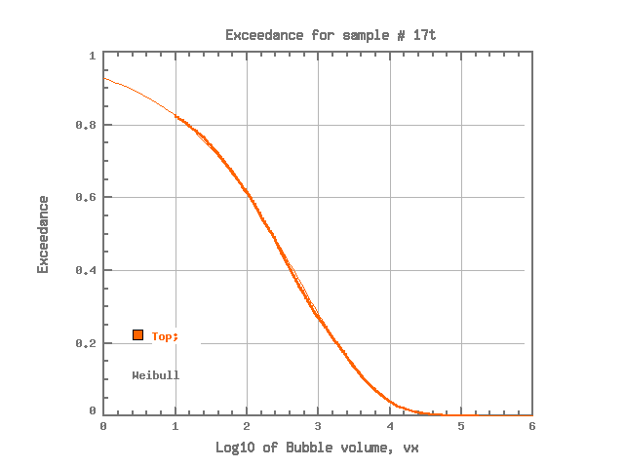  17t (Weibull)
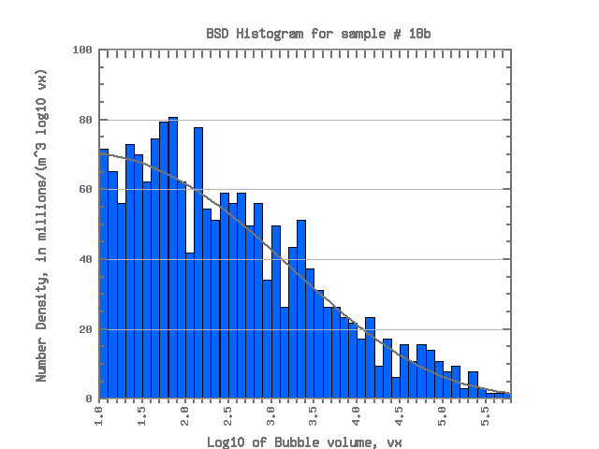  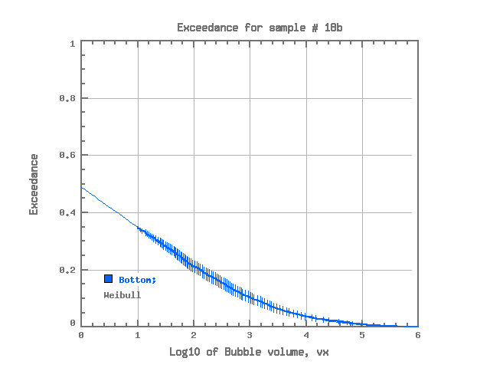  18b (Weibull) | 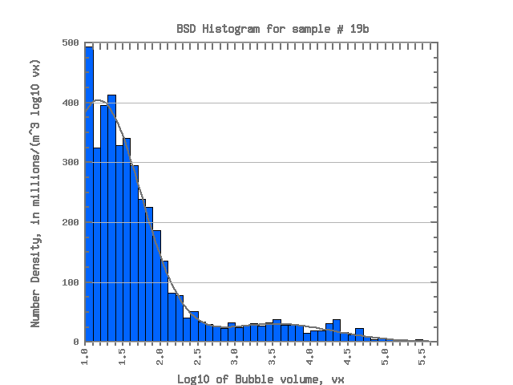  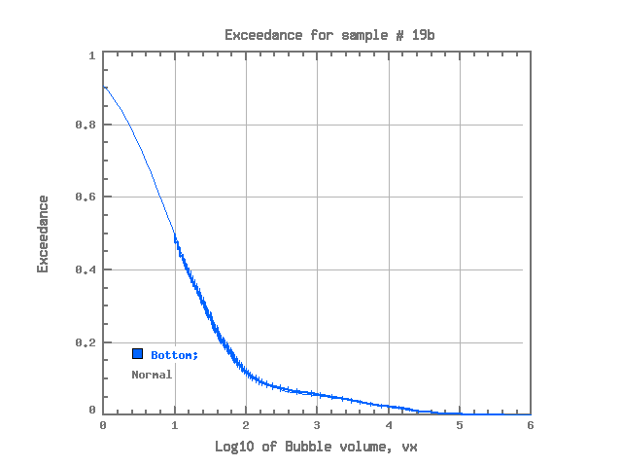  19b (Normal) | 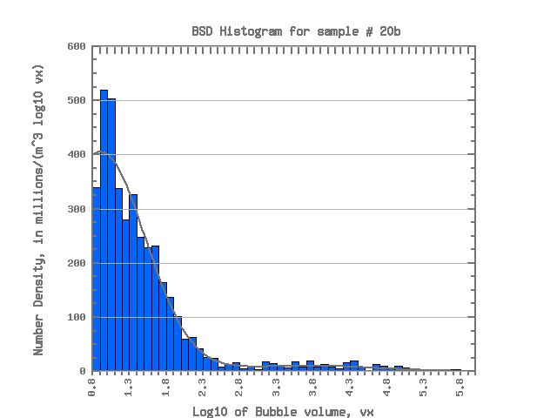  20b (Normal) | 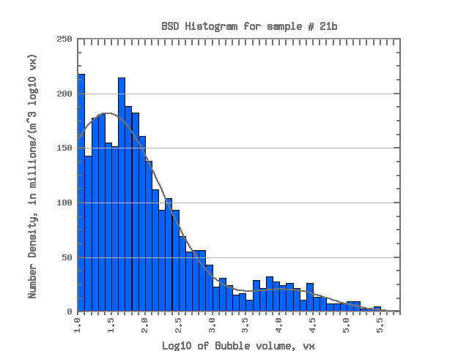  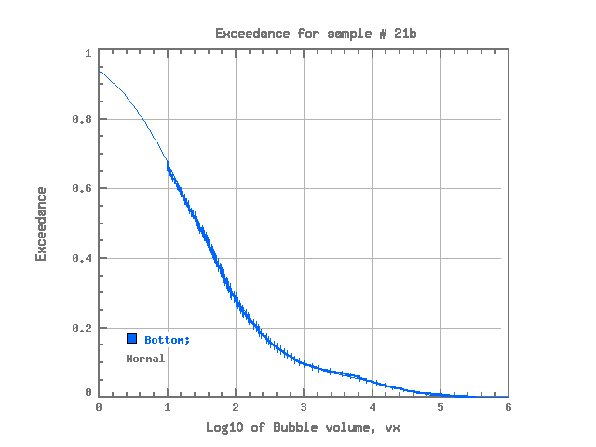  21b (Normal)
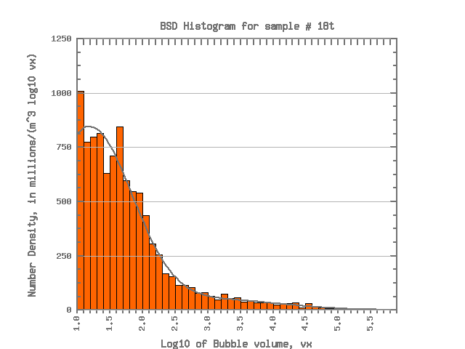  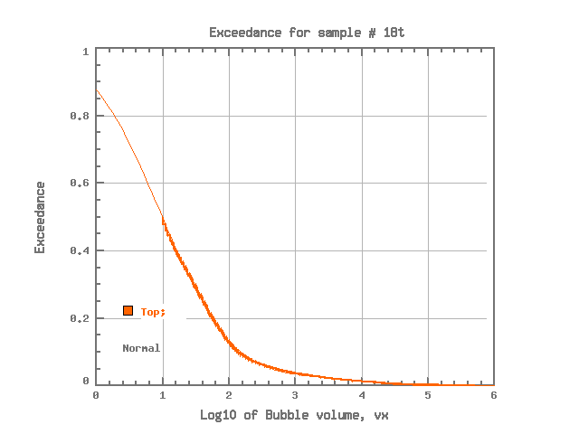  18t (Normal) | 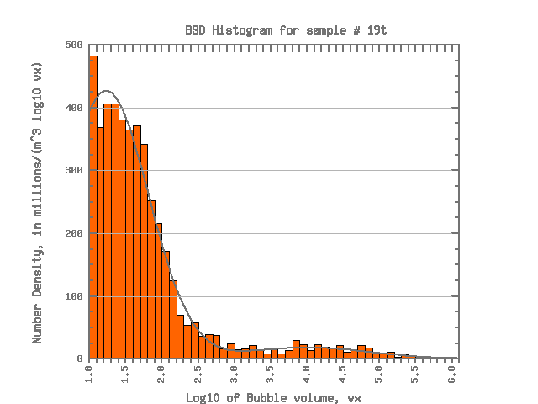  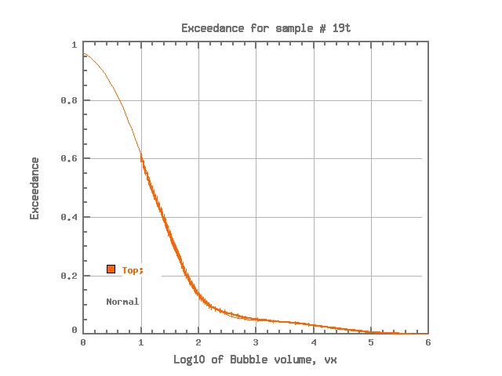  19t (Normal) | 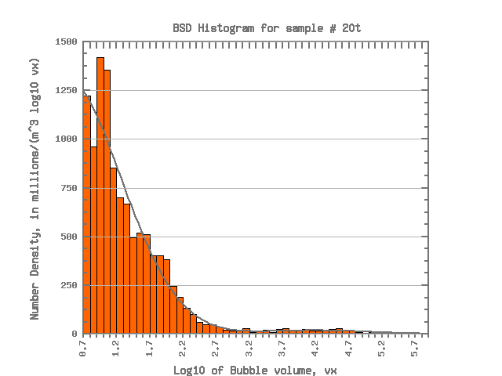  20t (Normal) | 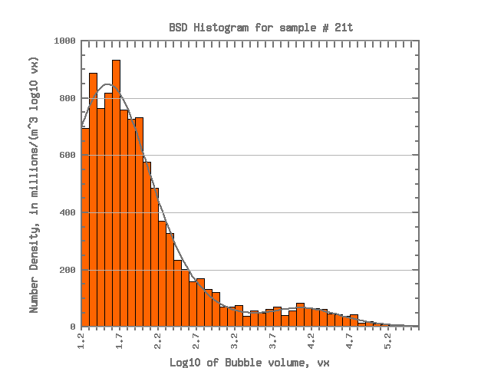  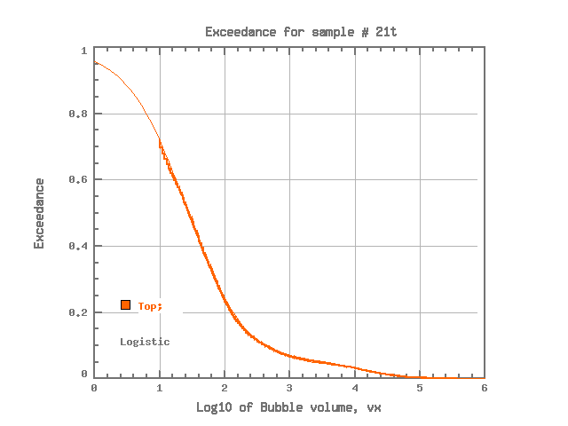  21t (Logistic)
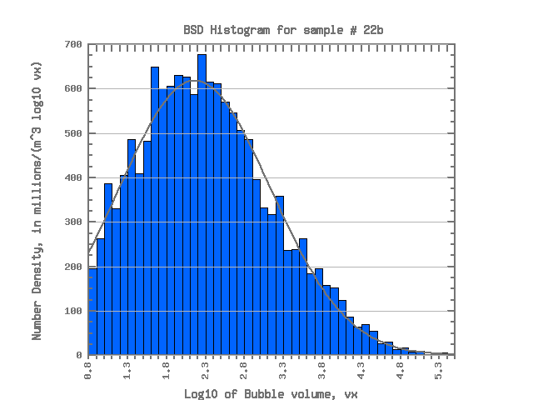  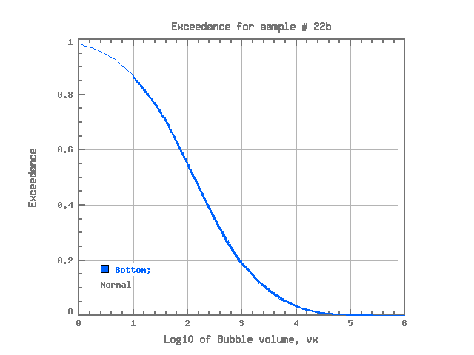  22b (Normal) | 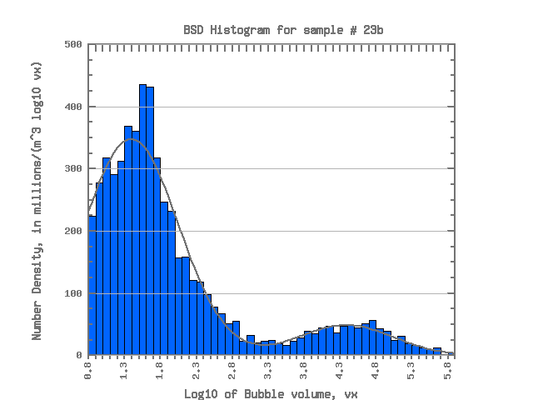  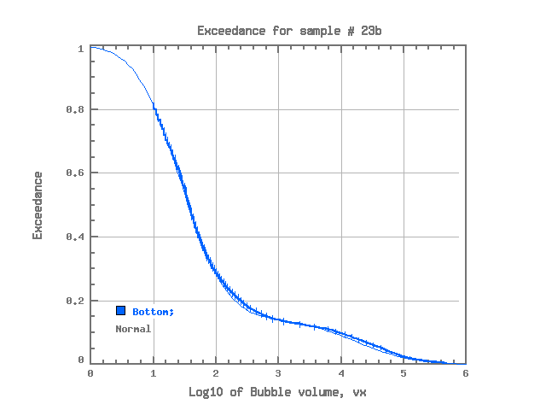  23b (Normal) | 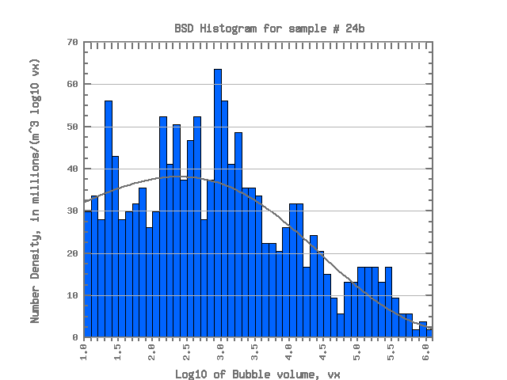  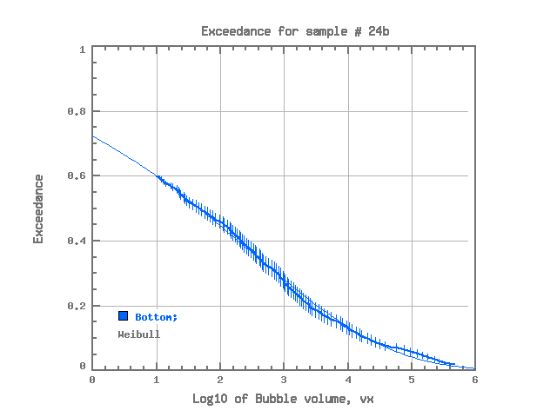  24b (Weibull) | 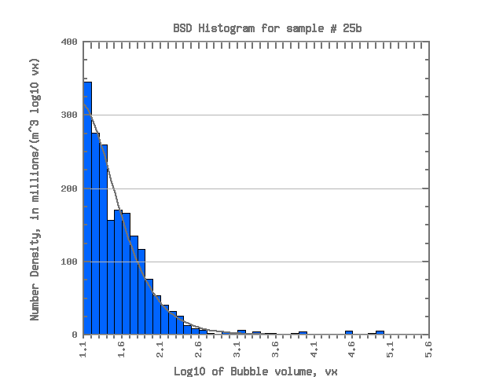  25b (Logistic)
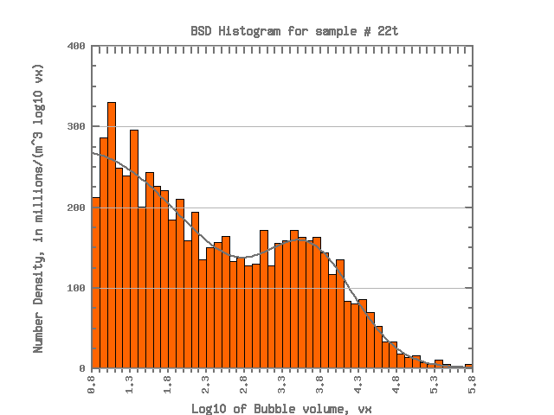  22t (Normal) | 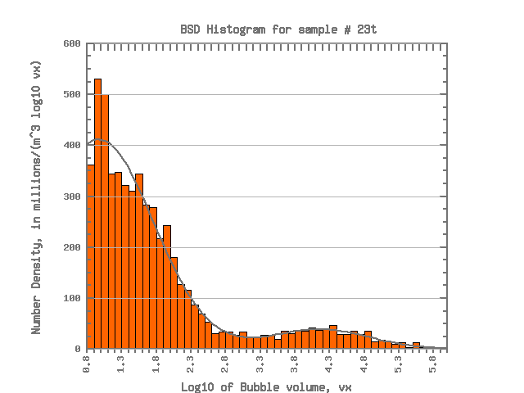  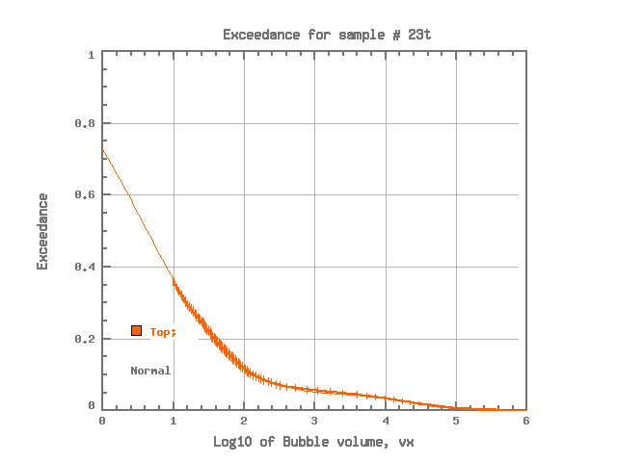  23t (Normal) | 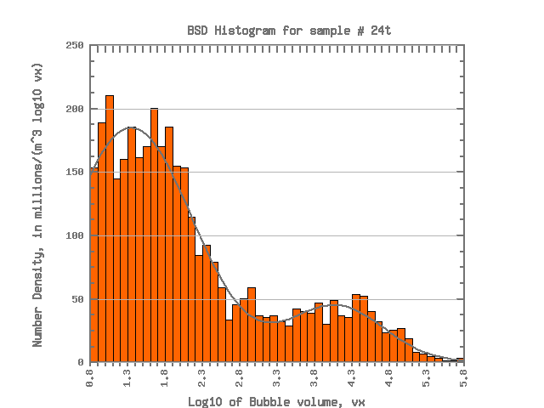  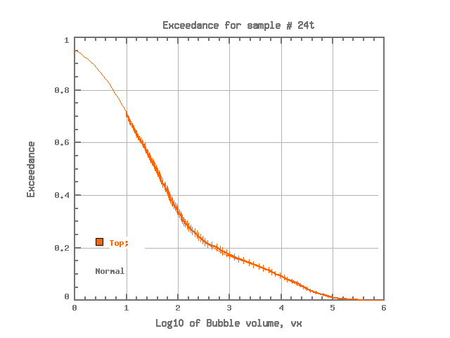  24t (Normal) | 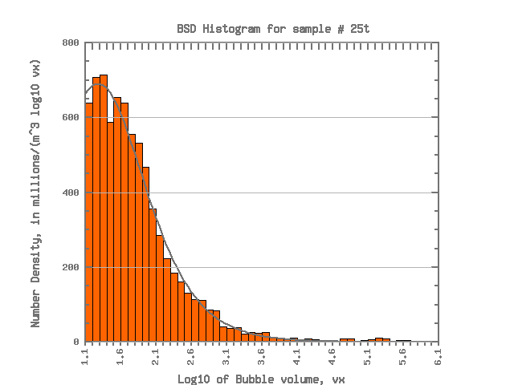  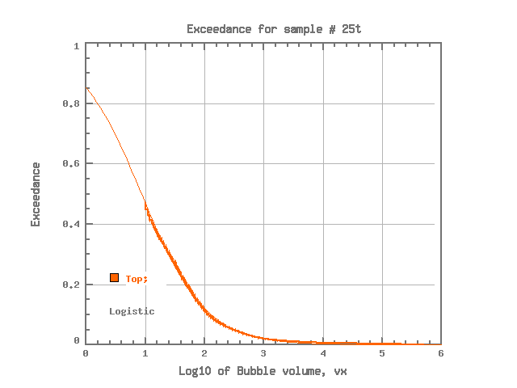  25t (Logistic)
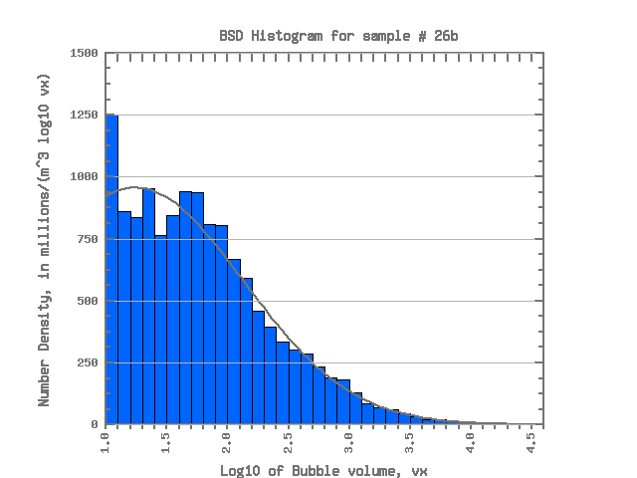  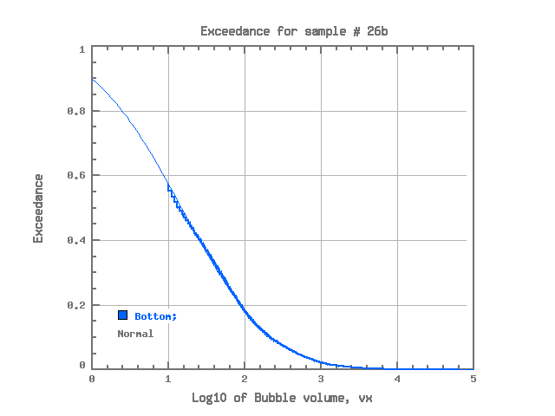  26b (Normal) | 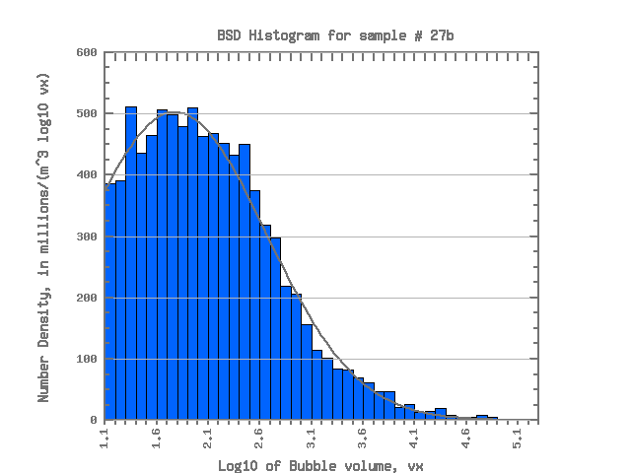  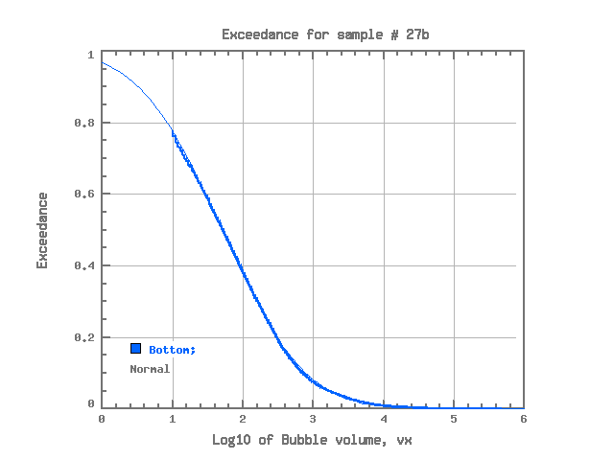  27b (Normal) | 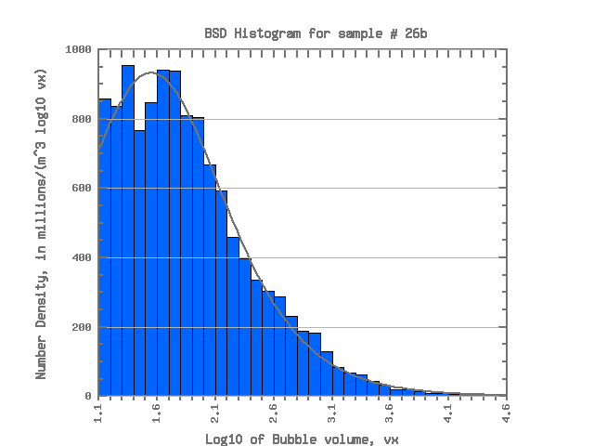  28b (Logistic) | 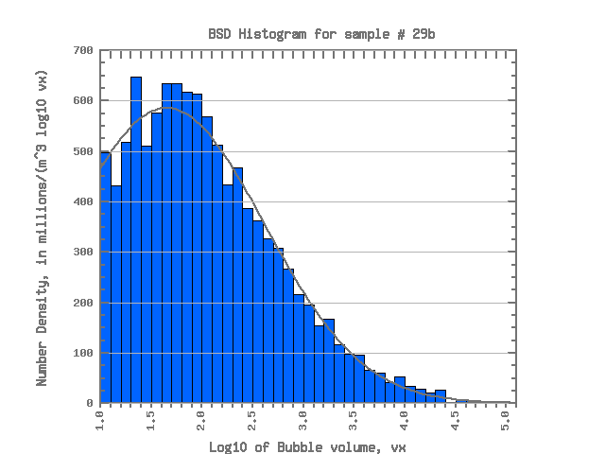  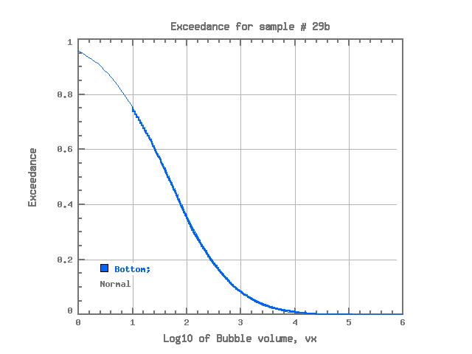  29b (Normal)
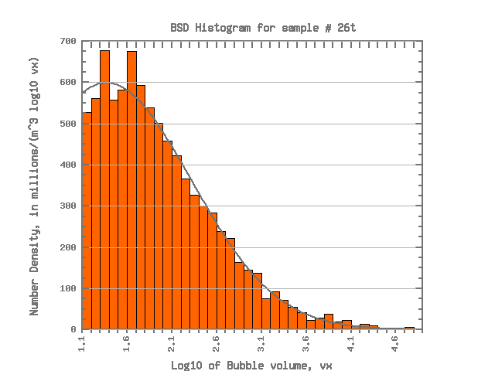  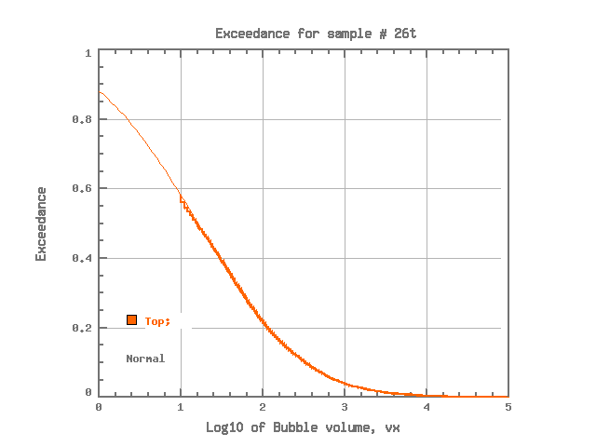  26t (Normal) | 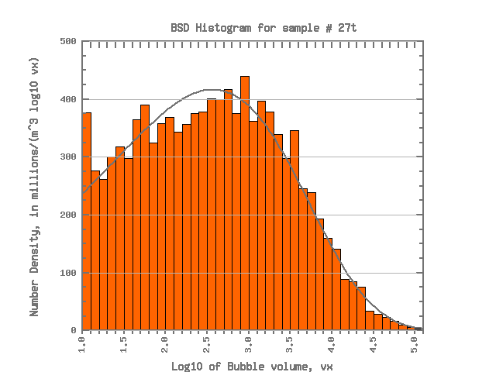  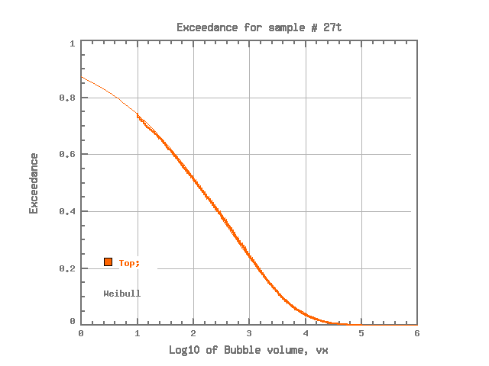  27t (Weibull) | 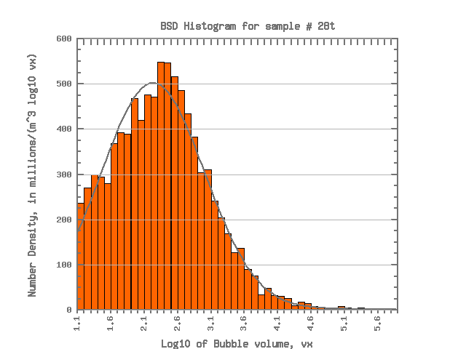  28t (Normal) | 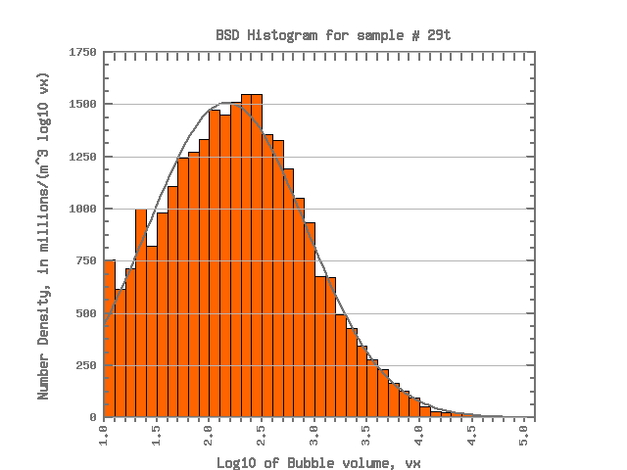  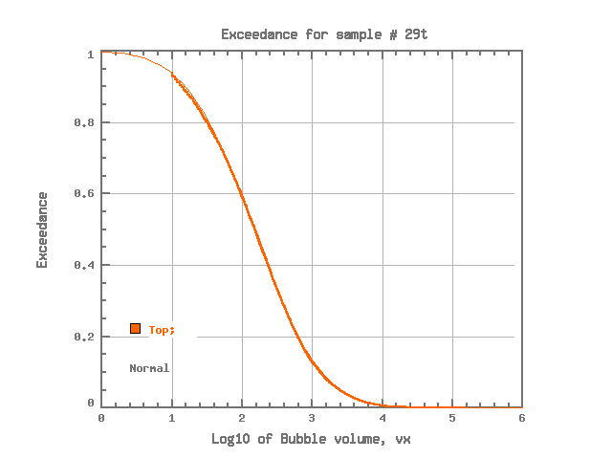  29t (Normal)
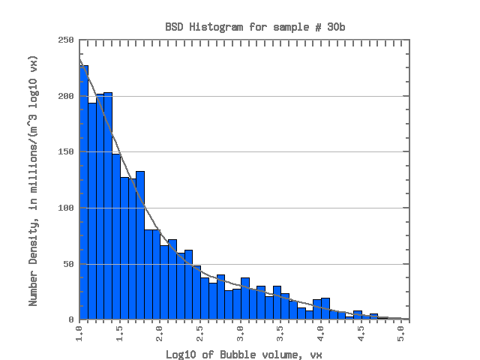  30b (Normal) | 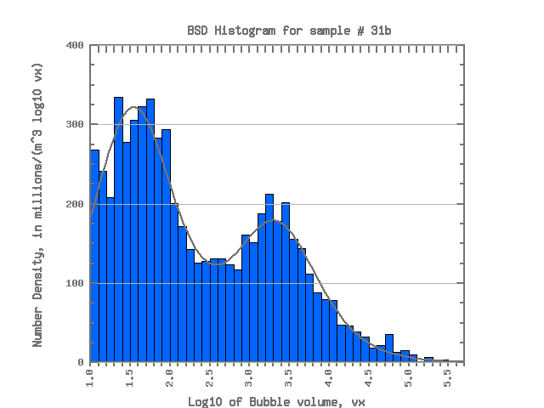  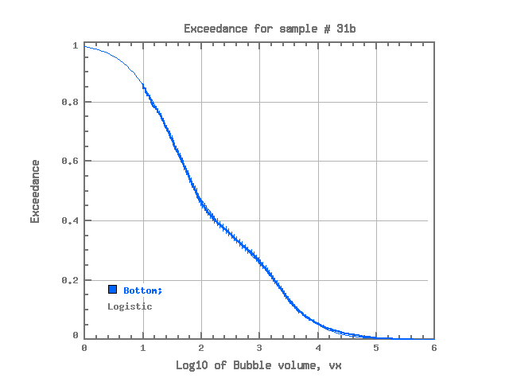  31b (Logistic) | 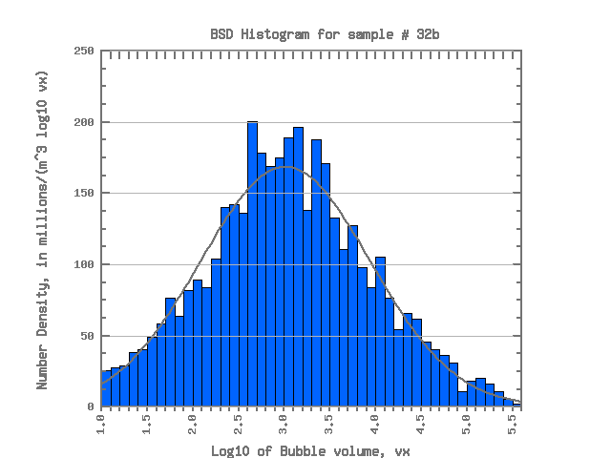  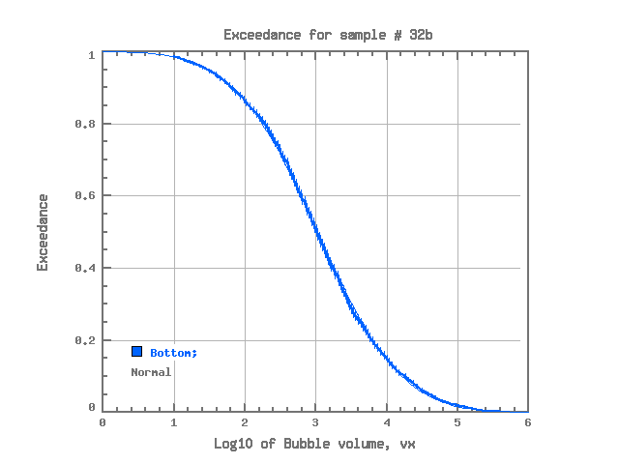  32b (Normal) | 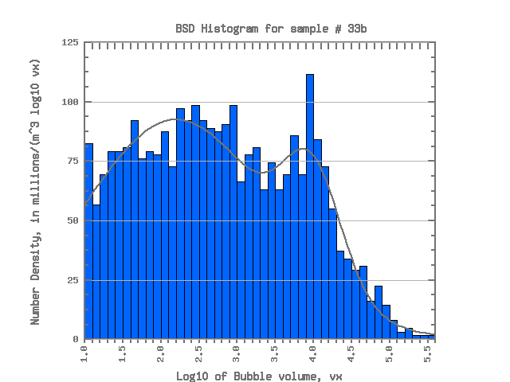  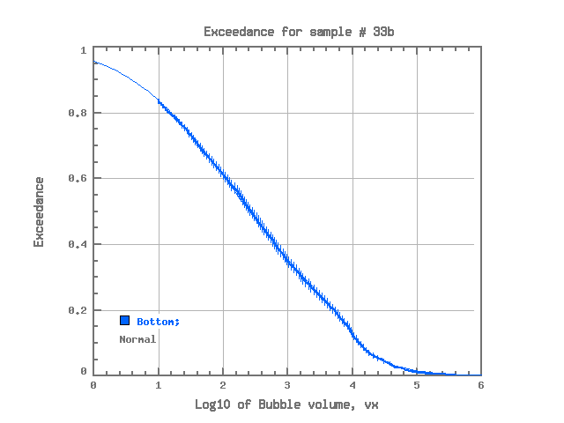  33b (Normal)
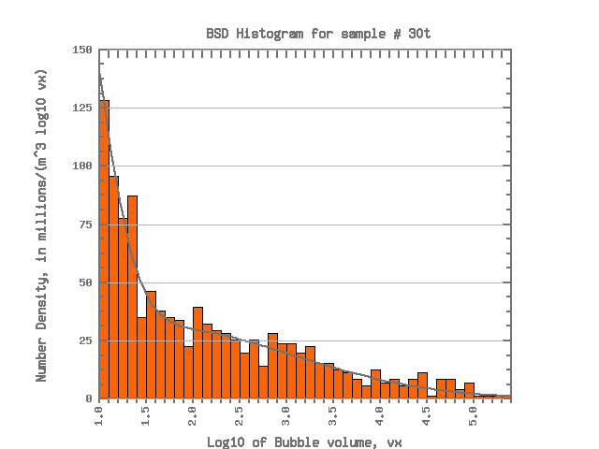  30t (Normal) | 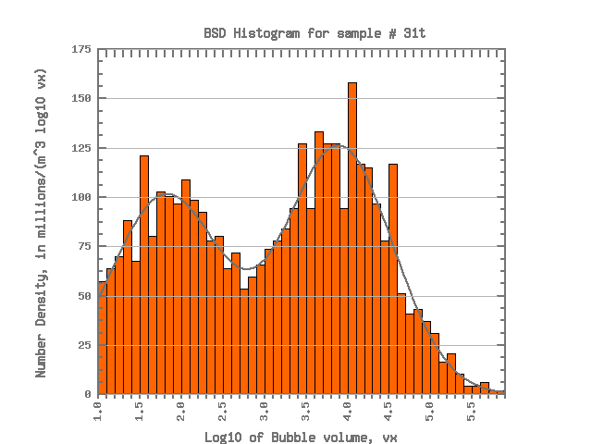  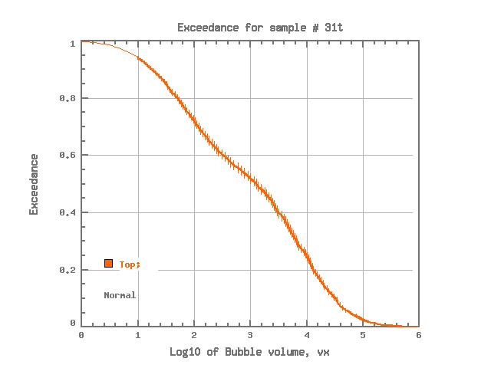  31t (Normal) | 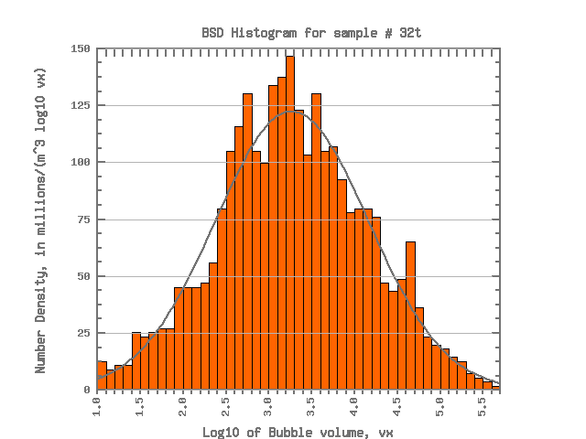  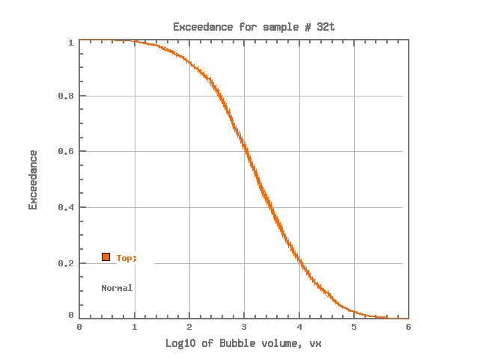  32t (Normal) | 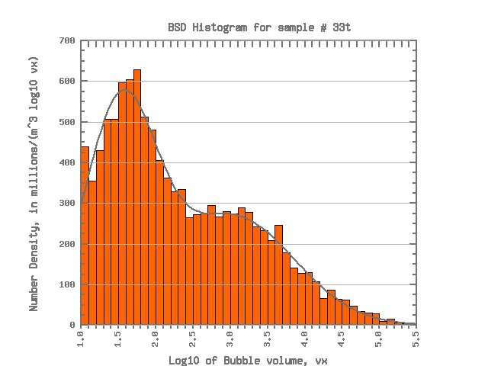  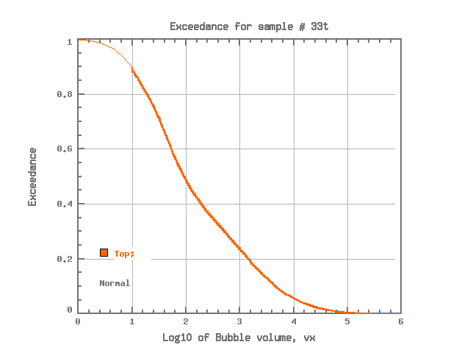  33t (Normal)
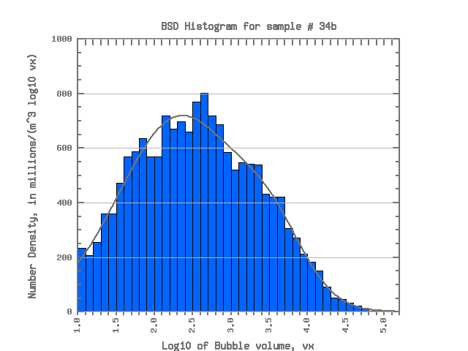  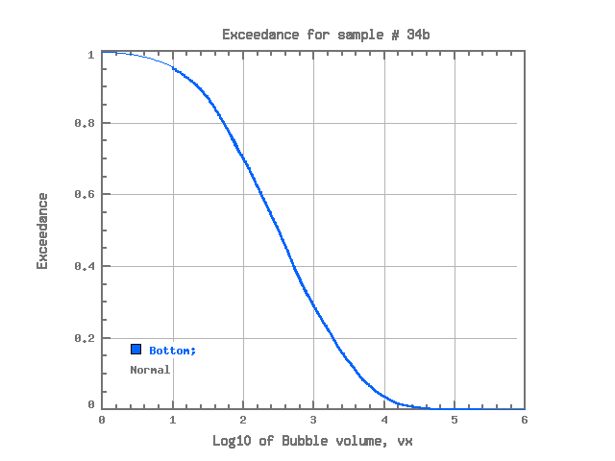  34b (Normal) | 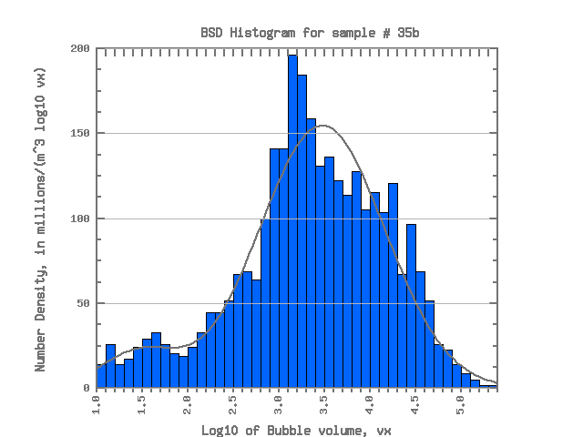  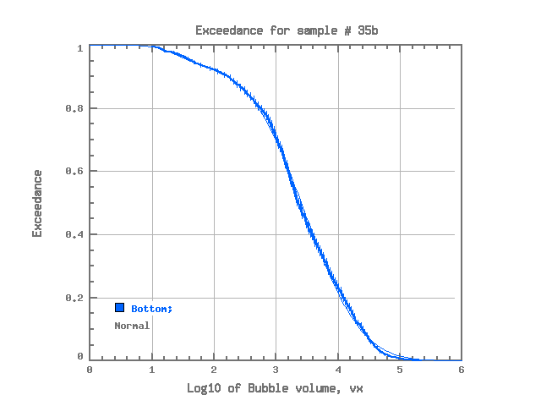  35b (Normal) | 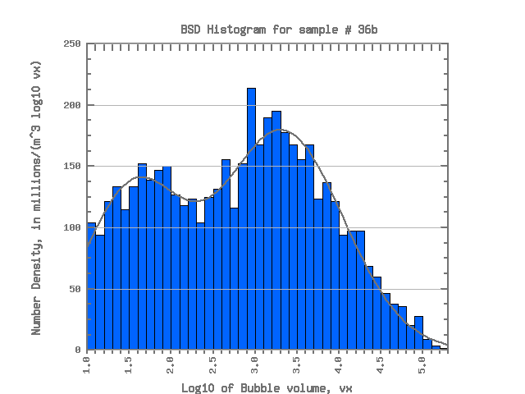  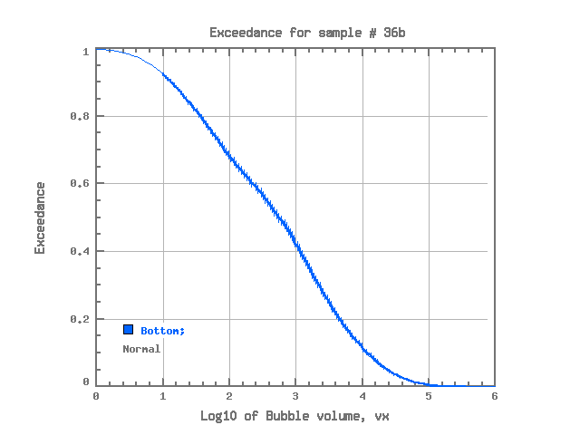  36b (Normal) | 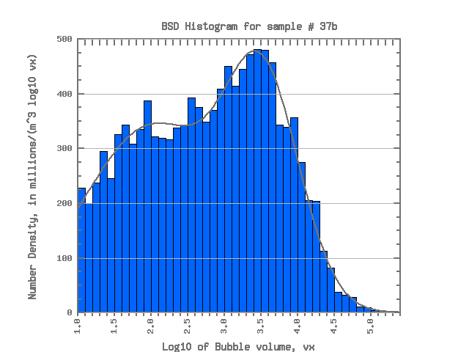  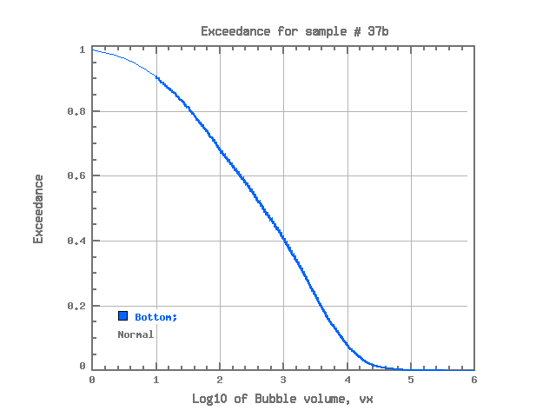  37b (Normal)
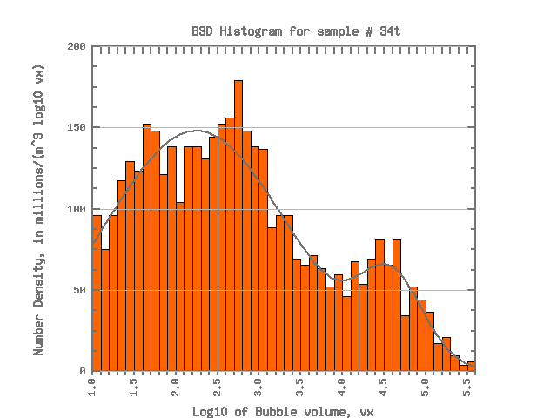  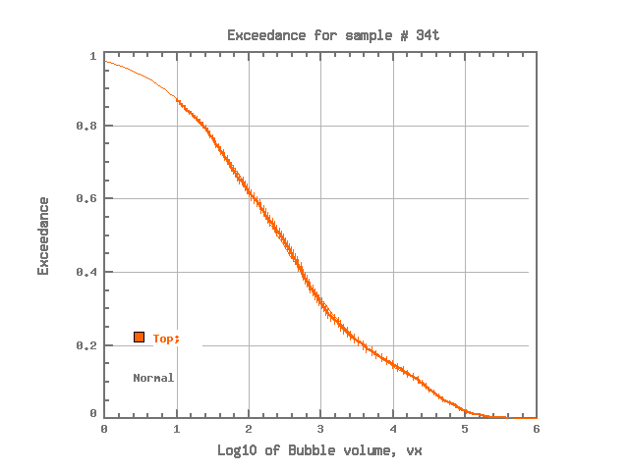  34t (Normal) | 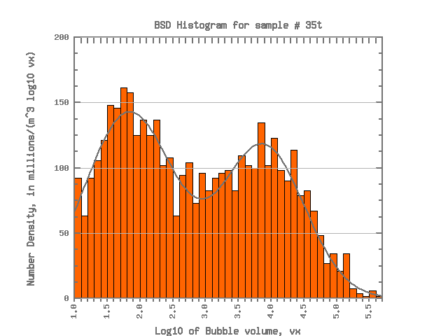  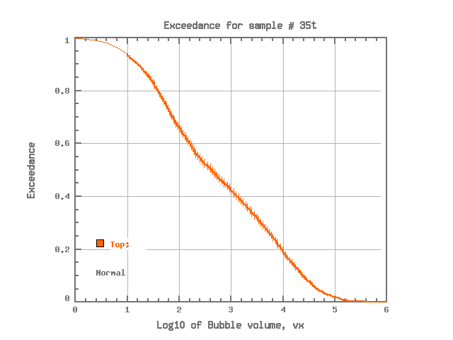  35t (Normal) | 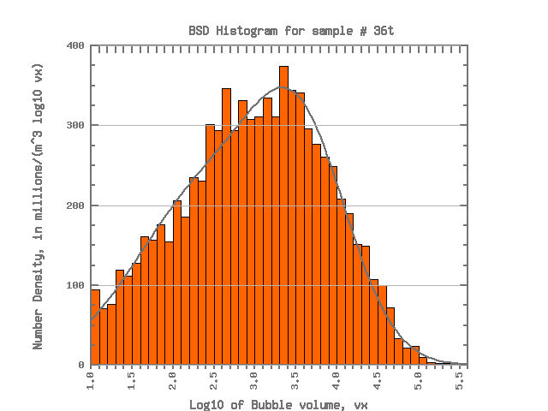  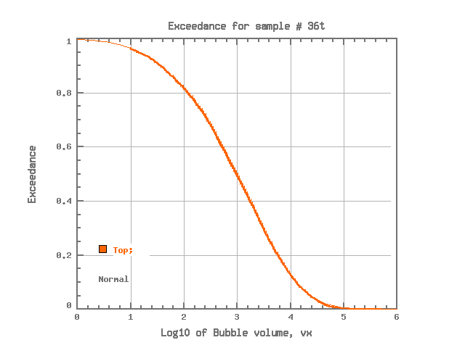  36t (Normal) | 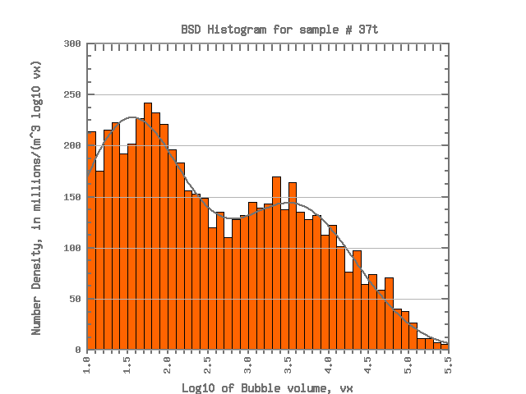  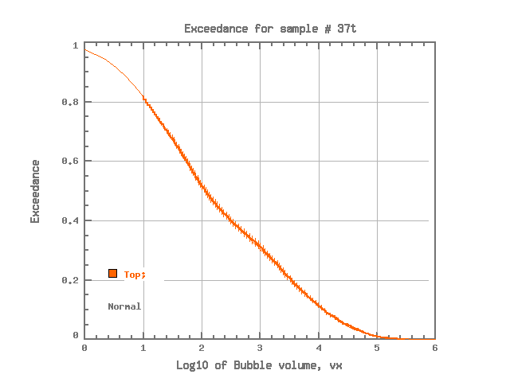  37t (Normal)
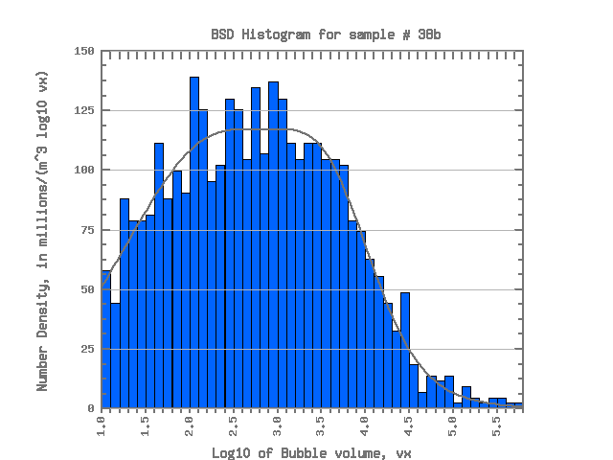  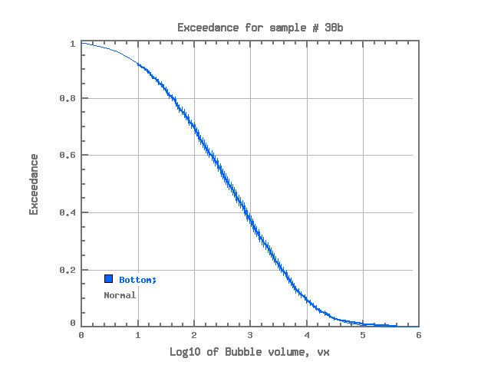  38b (Normal) | 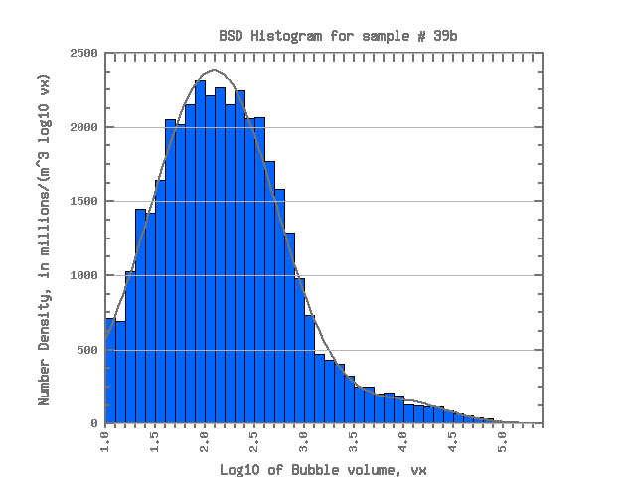  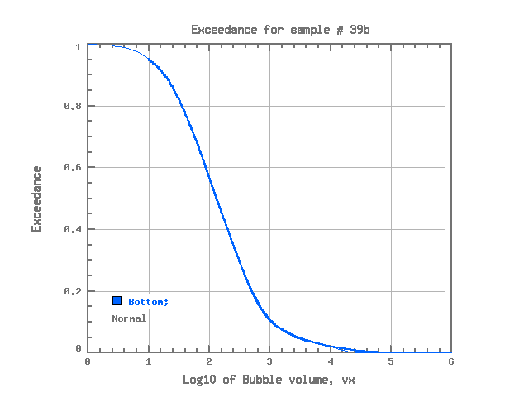  39b (Normal) | 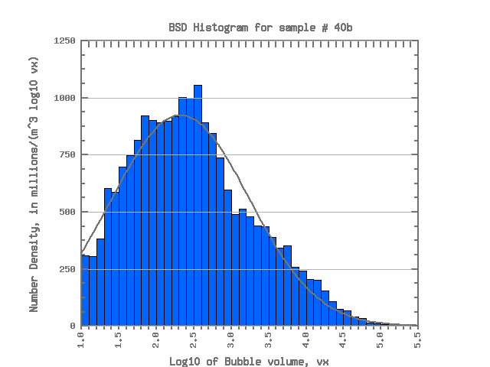  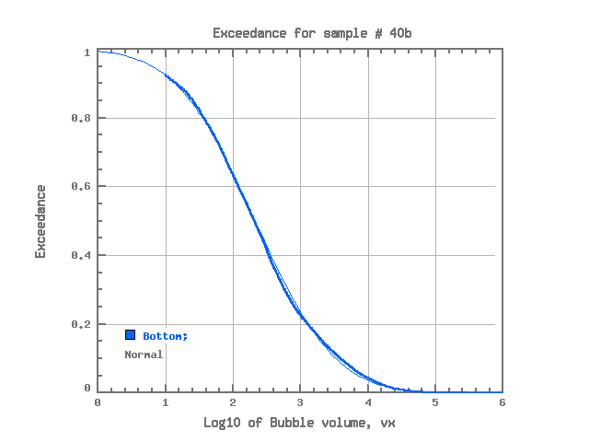  40b (Normal) | 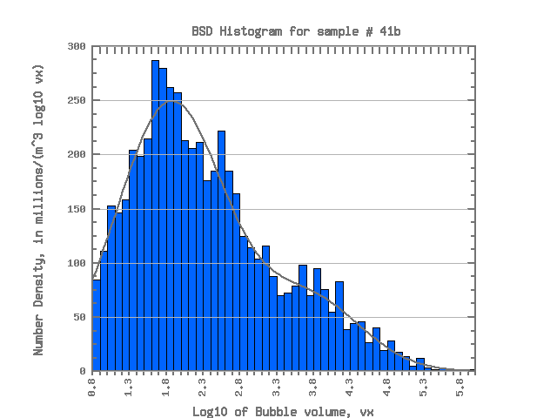  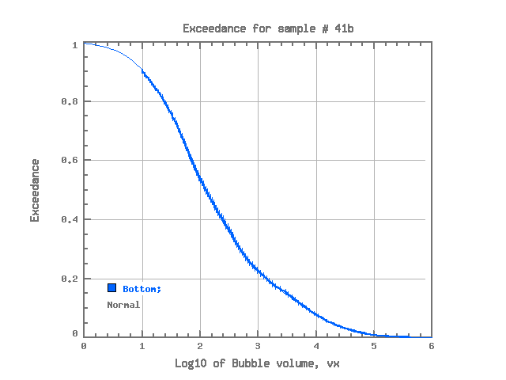  41b (Normal)
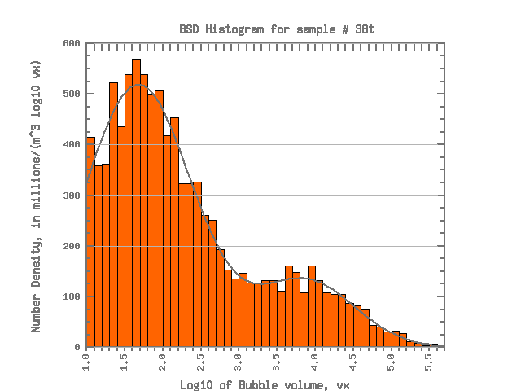  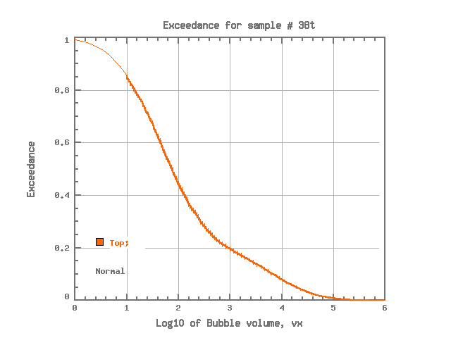  38t (Normal) | 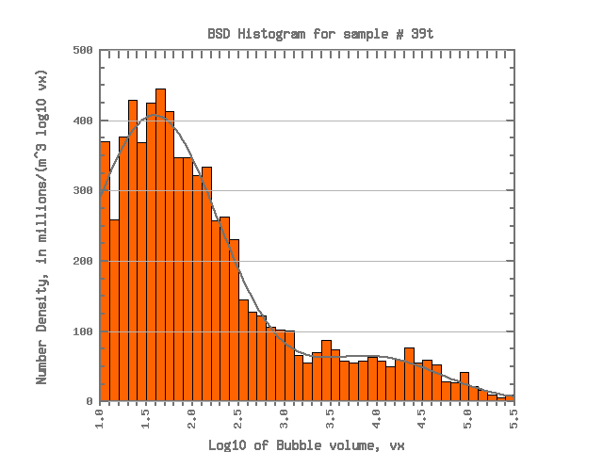  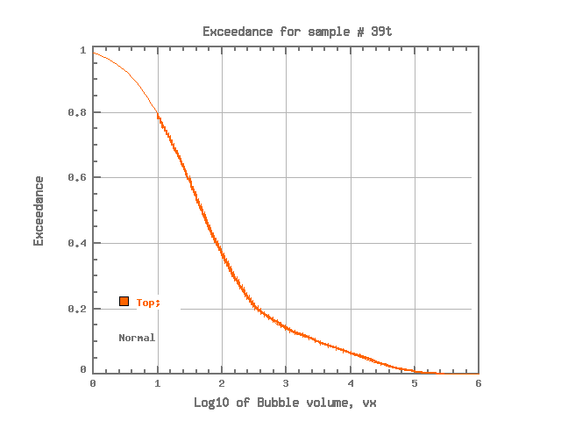  39t (Normal) | 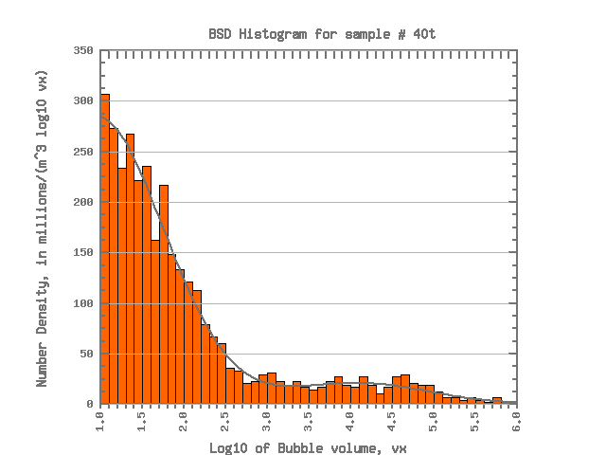  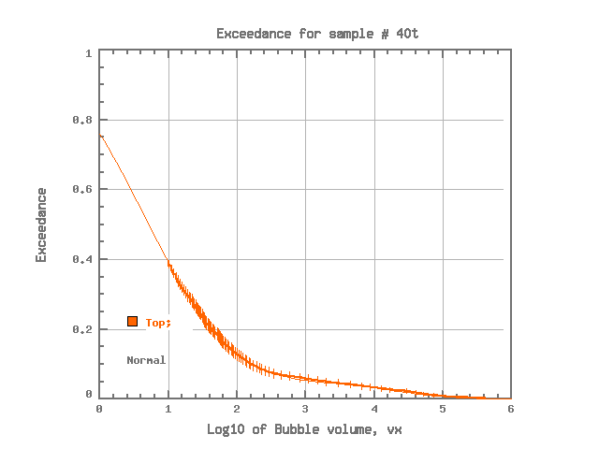  40t (Normal) | 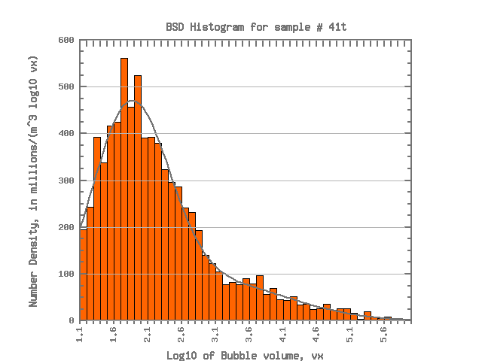  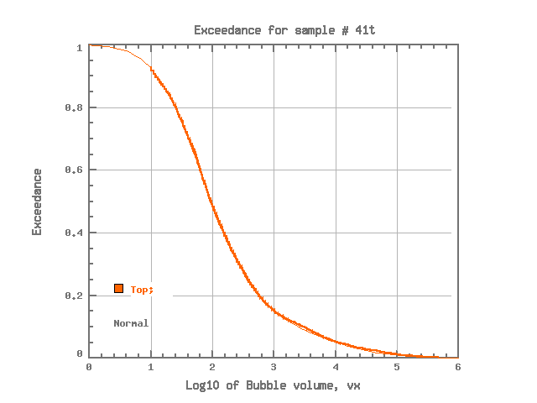  41t (Normal)
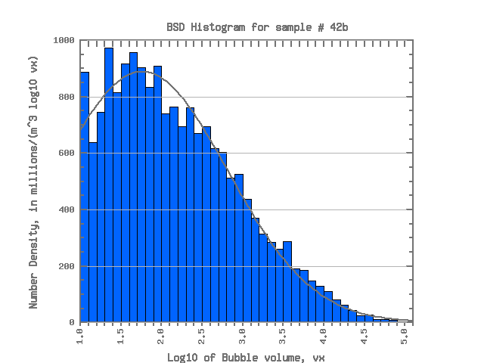  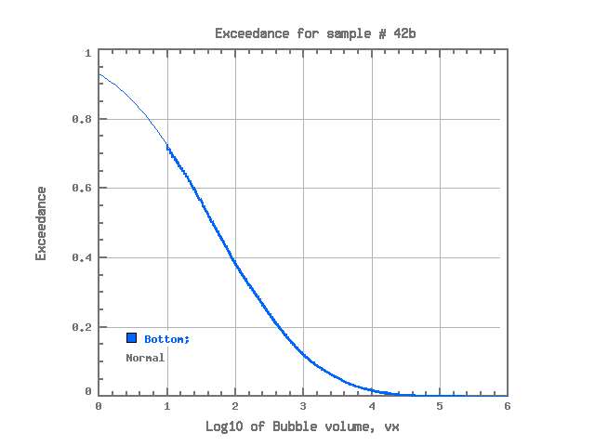  42b (Normal) | 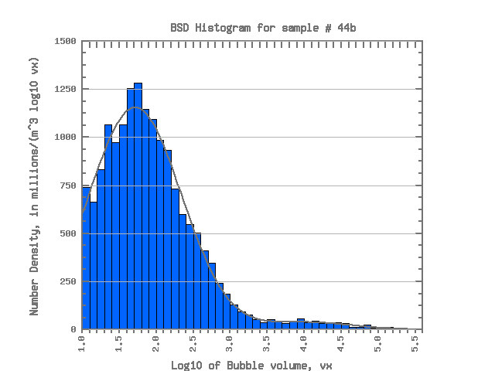  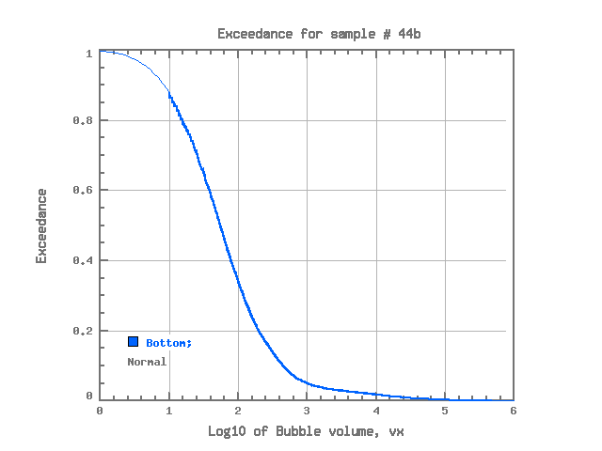  44b (Normal) | 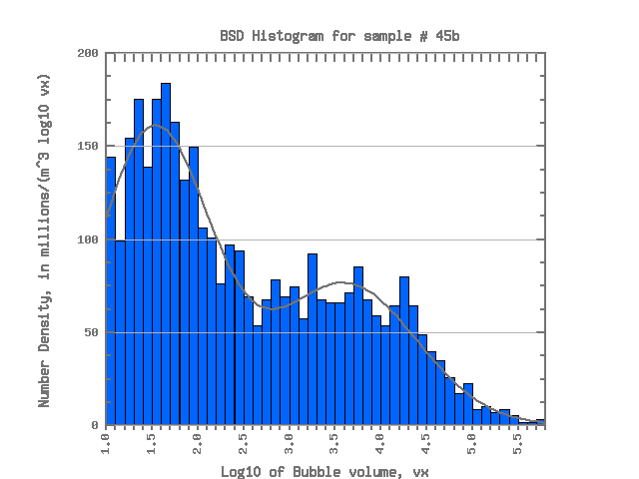  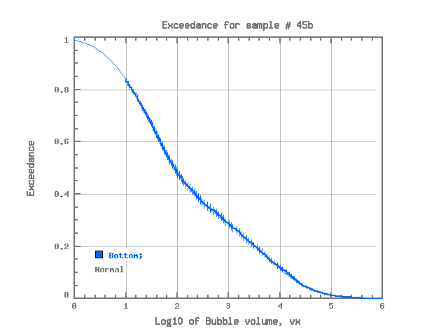  45b (Normal) | 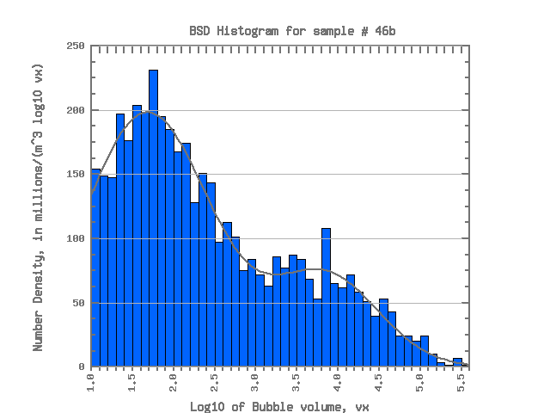  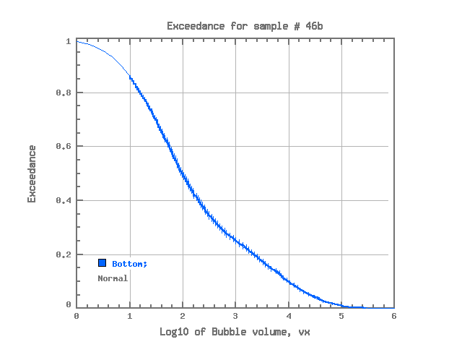  46b (Normal)
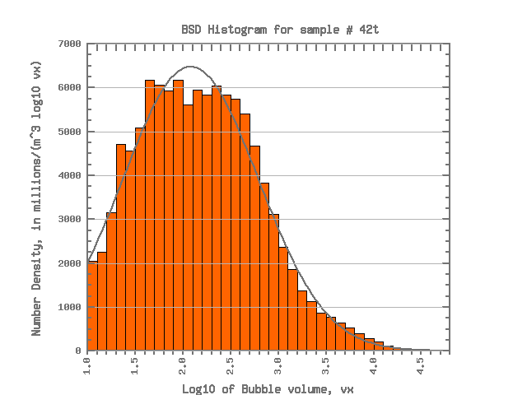  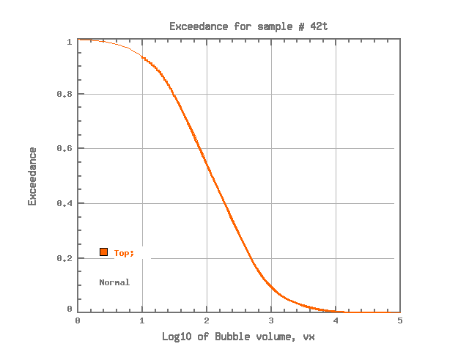  42t (Normal) | 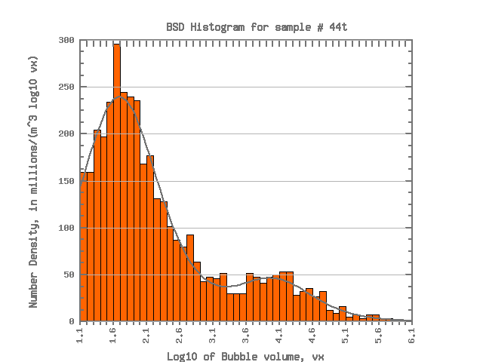  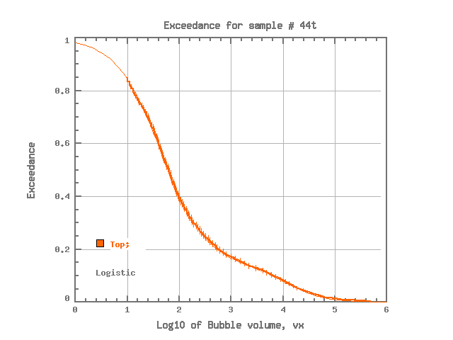  44t (Logistic) | 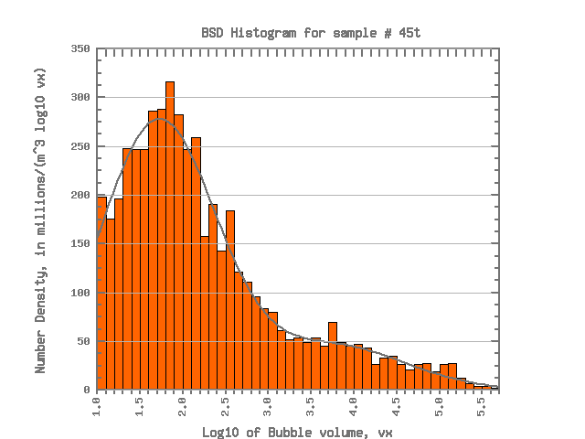  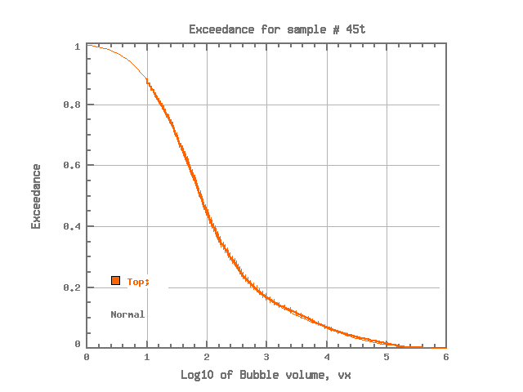  45t (Normal) | 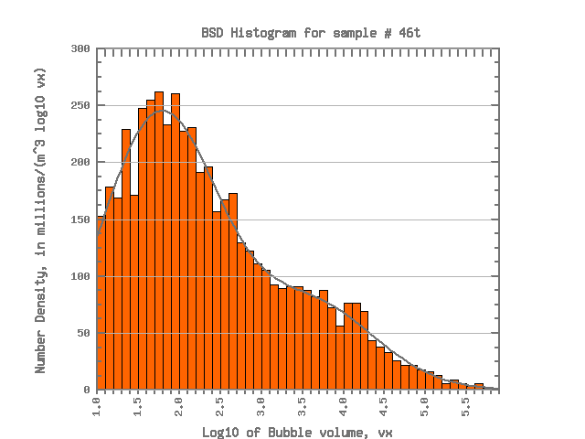  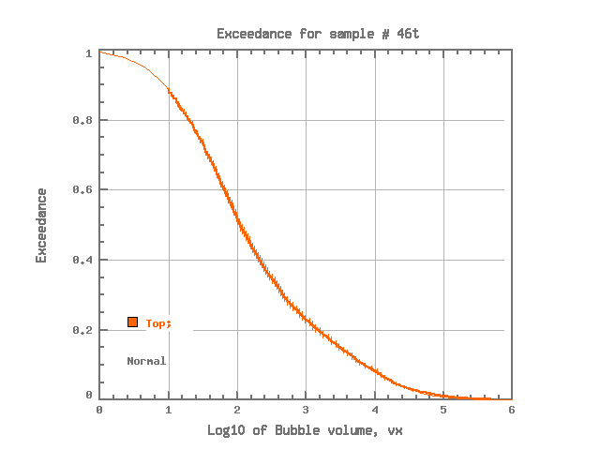  46t (Normal)
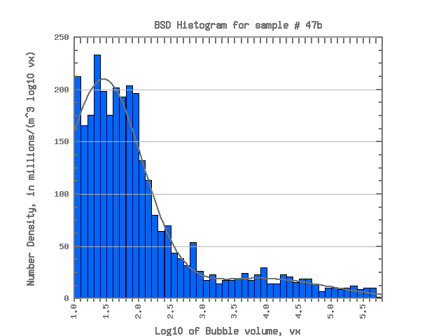  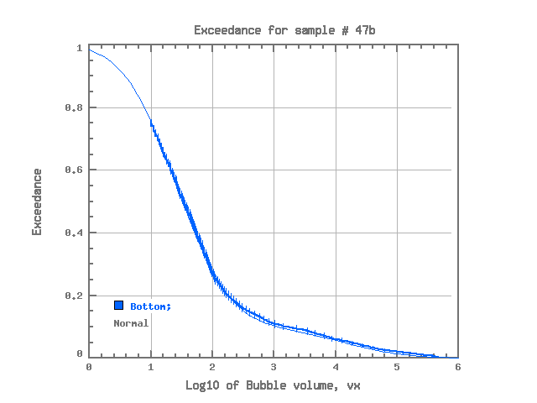  47b (Normal) | 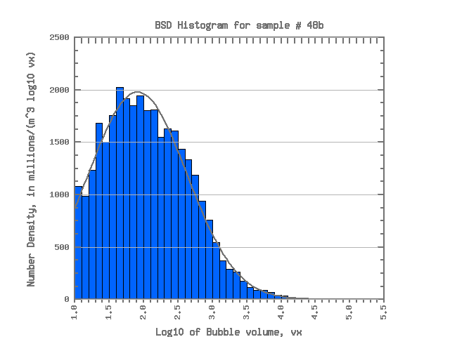  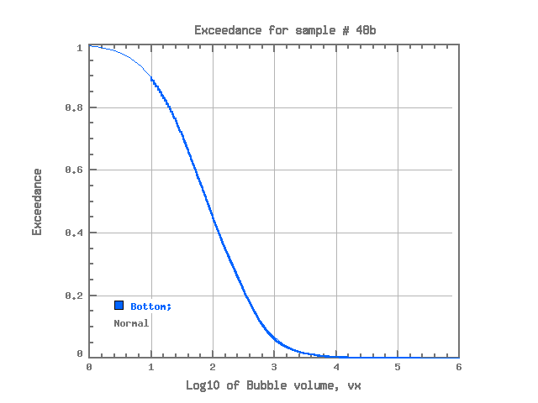  48b (Normal) | 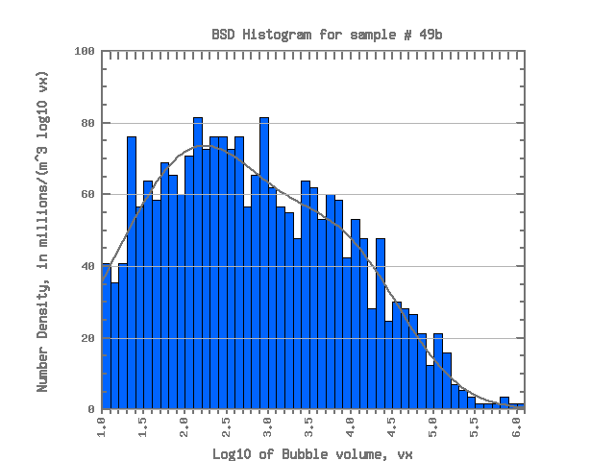  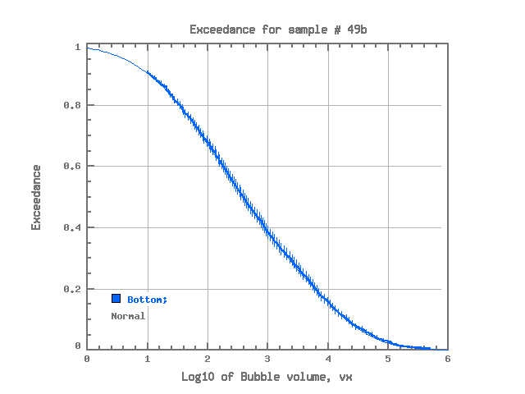  49b (Normal) | 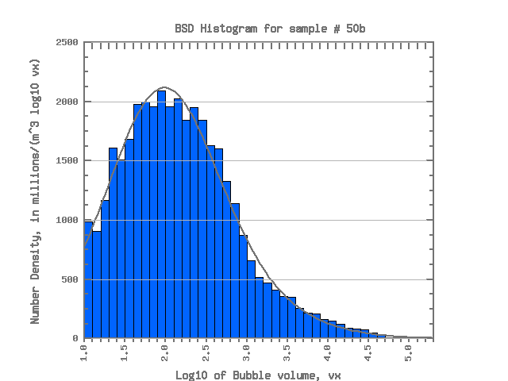  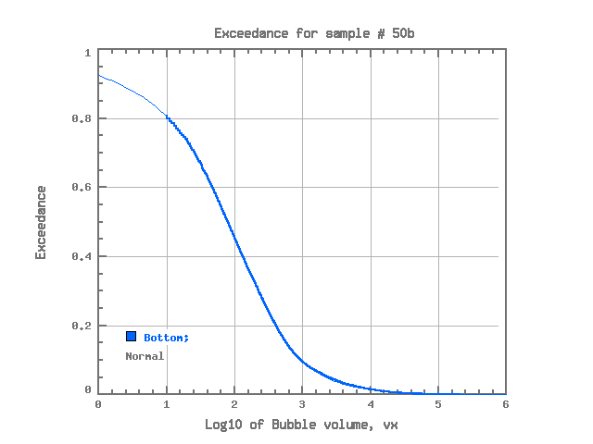  50b (Normal)
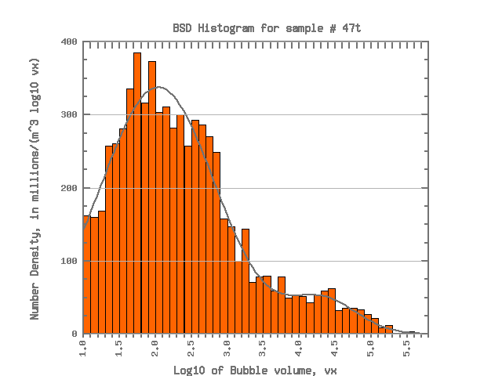  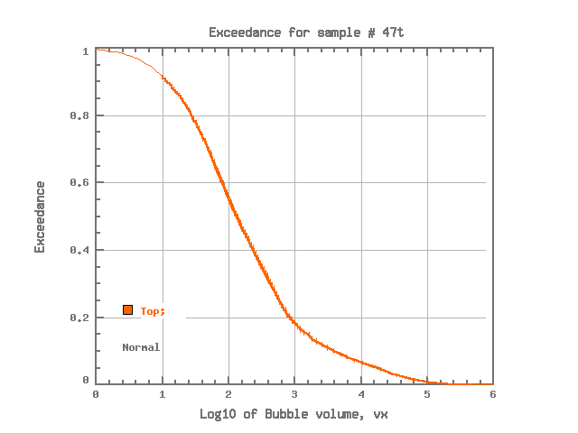  47t (Normal) | 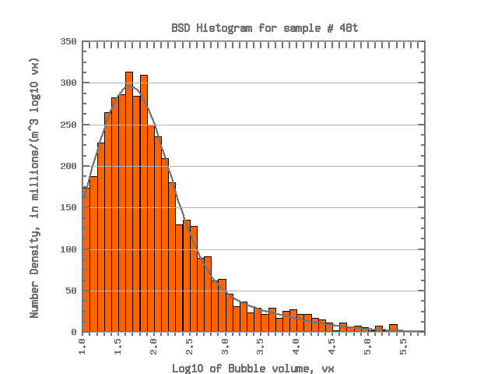  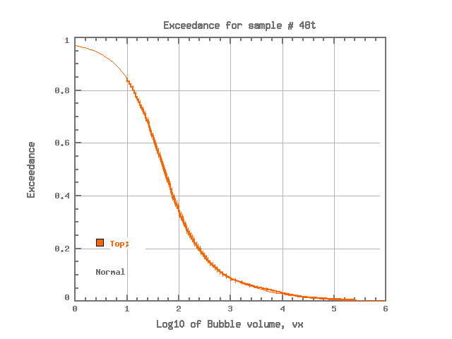  48t (Normal) | 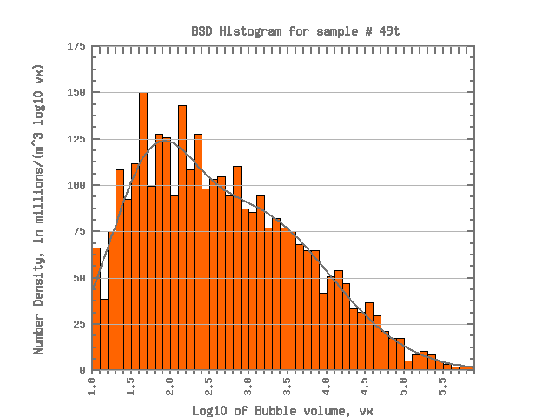  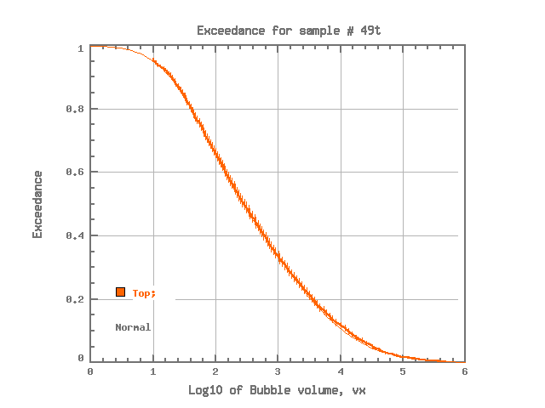  49t (Normal) | 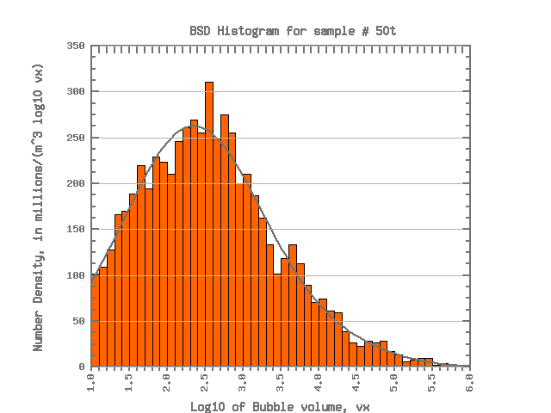  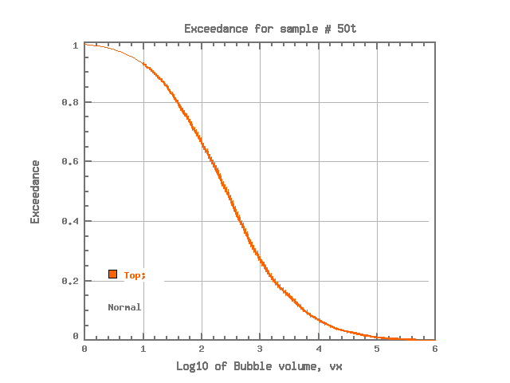  50t (Normal)

Table 2. Summary of best fit results presented in Table 1.
Distribution | Mono-modal | Bi-modal | Total
Normal | 18 | 52 | 70
Logistic | 6 | 11 | 17
Weibull | 9 | - | 9
Exponential | - | - | -
All | 33 | 63 | 96

Here and thereafter we omit “log” prefix from all distribution names since all of them belong to logarithmic family
Here and thereafter we refer chi-square as its normalized value to degrees of freedom. This way its value shows how close it follows observation points, and deviation distance is measured by a unit of observation error (sigma).

